

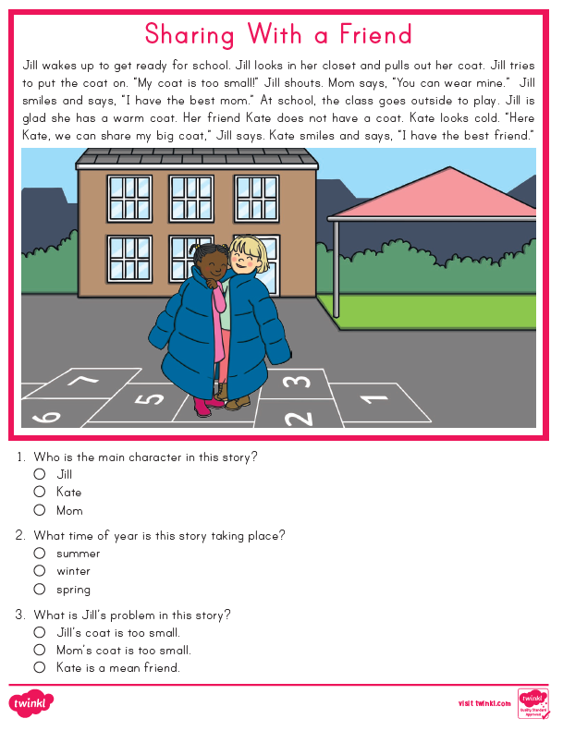
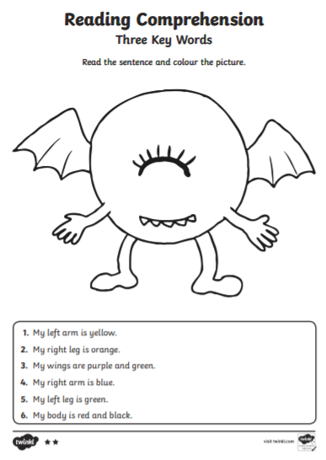
Tuesday


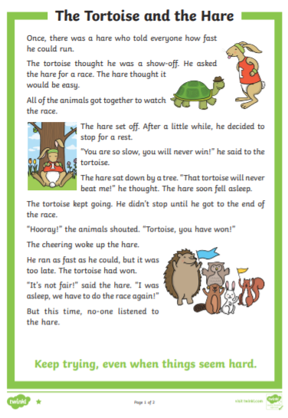
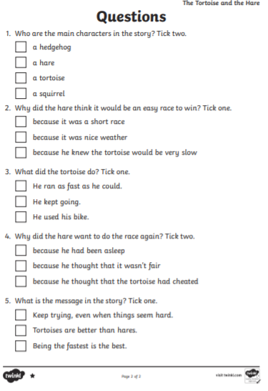
Drag the circle to choose you answer:

Constructing a Procedure
I will be successful if:
- I read the questions carefully
- I think about my answers before I start the activity
- I check my answers before I tell the teacher I am finished

Fill in the parts of the procedure below so that they are in order.

One has already been done for you.
Extension: add adverbs and adjectives

Ingredients | Equipment

Place the two pieces of fresh bread into the toaster.
Spread the soft butter onto both pieces of toast.
How to make Nutella toast!
For a delicious breakfast or snack that all the family will enjoy!
Catch the toast from the toaster and quickly place it on the plate!
Use the knife to spread the Nutella on top and enjoy!
2 pieces of fresh bread | 1 toaster | 1plate | 1 knife | Soft butter | Nutella

Maths
1st activity
Find 12 items and sort them into:
1(a) 2 groups of 6
(b) 2 x 6 =

2. (a) 3 groups of 4

(b) 3 x 4 =

3. (a) 6 groups of 2

(b) 6 x 2 =

4 (a) 4 groups of 3

(b) 4 x 3 =

2nd activity

Work out the answer to these multiplication questions.

- If had 4 friends over for my birthday and I wanted to make sure that they each had 2 cupcakes each. How many cupcakes would I need to make? Show your working.

- If 5 students borrowed 3 books each from the library, how many books did the 5 students borrow altogether from the library? Show your working.

3rd activity
2 times tables

Remember number fact rule for the 2 times tables is to Double It. For example, 2 x 1 = is the same as double 1 equals 2.
Finish the 2 x tables the first 2 have been done for you.

2 x 0 = 0
2 x 1 = 2
2 x 3 =
2 x 4 =
2 x 5 =
2 x 6 =
2 x 7 =
2 x 8 =
2 x 9 =
2 x 10 =
2 x 11 =
2 x 12 =

PBL

Calming Sequences

A calming sequence is a list of things you do using your mind and body to calm you down.
Try the below calming sequences

Calming Sequence 1
Close your eyes
1 Hold Steady…
2 Hold Steady…
3 Hold Steady…
4 Hold Steady…
5 Hold Steady…
6 Hold Steady…
7 Hold Steady…
8 Hold Steady…
9 Hold Steady…
10 I’m Ready.

Calming Sequence 2

- Squeeze your hands together into fists
- Close your eyes
- Rub your head
- Rub your legs
- Repeat the sequence five times

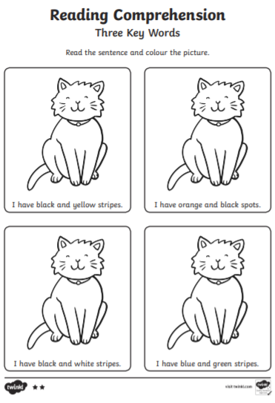
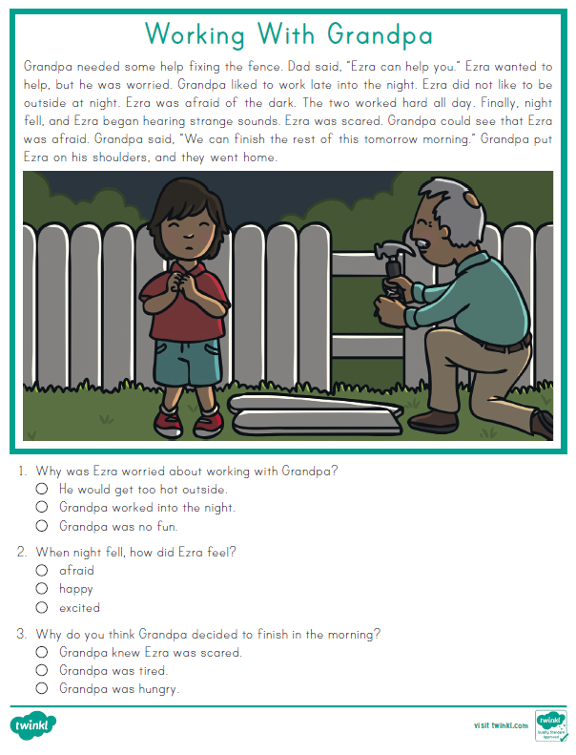
Wednesday
Drag the circle to choose you answer:

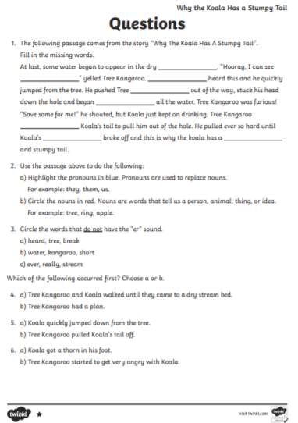
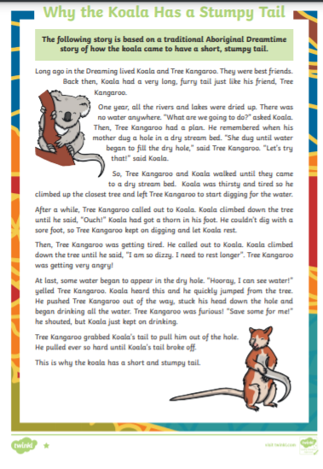
Drag the circle to choose you answer:

Constructing a Procedure
I will be successful if:
- I read the questions carefully
- I think about my answers before I start the activity
- I check my answers before I tell the teacher I am finished

Fill in the missing parts of the procedure below and write in order.

One has already been done for you.
Extension: add adverbs and adjectives

Ingredients | Equipment

Place the two pieces of fresh bread into the toaster.
Spread ____________________________________ onto both pieces of toast.
How to make disgusting toast!
A trick to give you brother or sister!
Catch the toast from the toaster and quickly place it on the plate!
Use the knife to spread __________________________ on top and enjoy!
2 pieces of fresh bread | 1 toaster | 1 plate | 1 knife

Maths

1st activity

Find 24 items and sort them into:

1 (a) 2 groups of 12

(b) 2 x 12 =

2 (a) 3 groups of 8

(b) 3 x 8 =

3 (a) 4 groups of 6

(b) 4 x 6 =

4 (a) 12 groups of 2

(b) 12 x 2 =

5 (a) 8 groups of 3

(b) 8 x 3 =

6 (a) 6 groups of 4
(b) 6 x 4 =

2nd activity

Multiplication Word Problems

- If 5 students had 4 pencils each, how many pencils did the 5 students have altogether? Show your working.

- A farmer planted 6 rows of beans with 3 bean plants in each row. How many bean plants did the farmer plant altogether? Show your working using an array then answer 6 x 3 =

- John bought 4 packets of biscuits that had 8 biscuits in each packet. How many biscuits are there altogether? Show your working.

3rd activity

3 x tables

The rule for the 3 x tables is, double it then add itself. For example, we can work out 3 x 4 by doubling 4 which gives us 8 then adding 4 to 8 which equals 12. Then 3 x 4 = 12.
Complete the below 3 times tables.

3 x 0 =
3 x 1 =
3 x 2 =
3 x 3 =
3 x 4 =
3 x 5 =
3 x 6 =
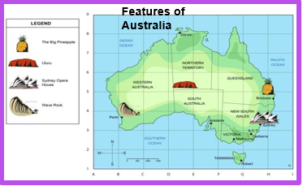
3 x 7 =
3 x 8 =
3 x 9 =
3 x 10 =
3 x 11 =
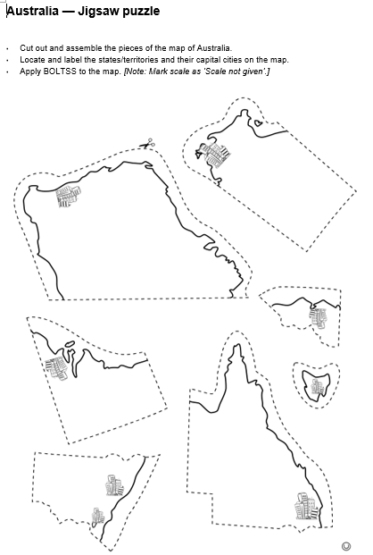
3 x 12 =
HASS

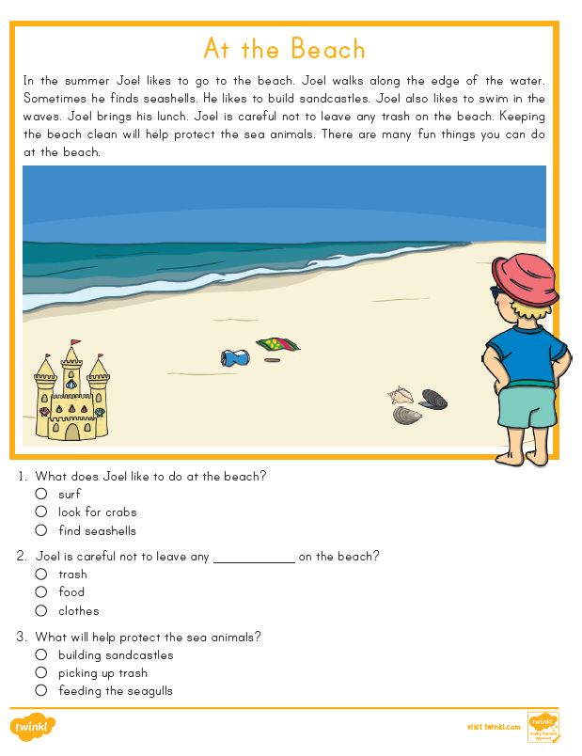
Thursday
Drag the circle to choose you answer:
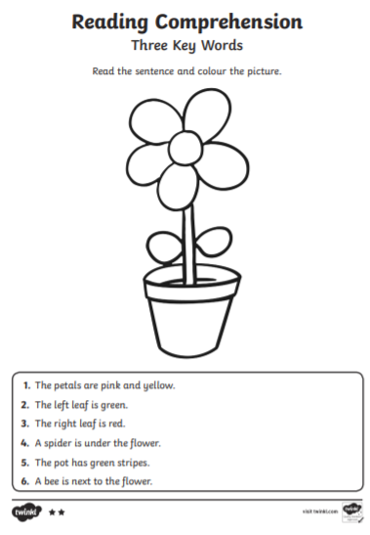
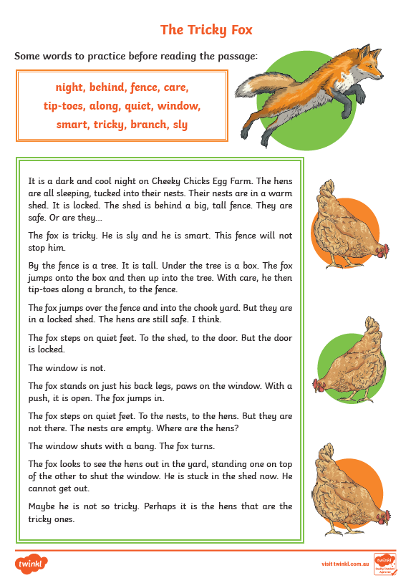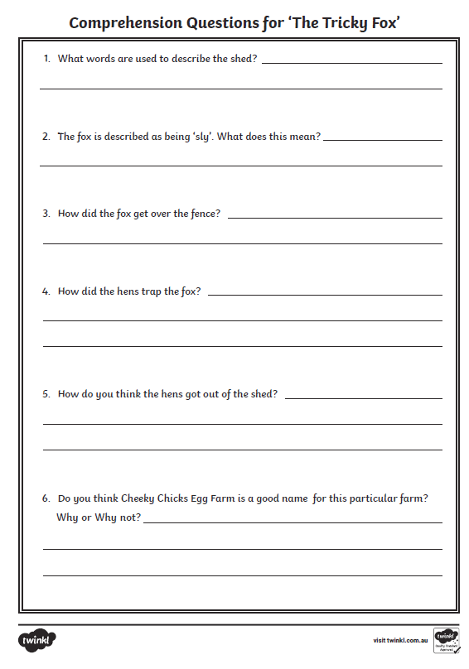

Constructing a Procedure
I will be successful if:
- I read the questions carefully
- I think about my answers before I start the activity
- I check my answers before I tell the teacher I am finished

Fill in the parts of the procedure below and make sure you write in order.

Don’t forget your headings.
Extension: add adverbs and adjectives
You could also add something extra.

Place the milk, ice-cream and flavouring in a blender.
Press the blender on.
How to make a milk shake!
A delicious treat!
Pour into a large glass.
Enjoy slurping your milkshake!
Ice-cream | milk | flavouring | blender | glass

Maths
1st activity
Split Strategy
The numbers in the equation are ‘split’ into tens and ones and added or subtracted separately and then they are put back together.
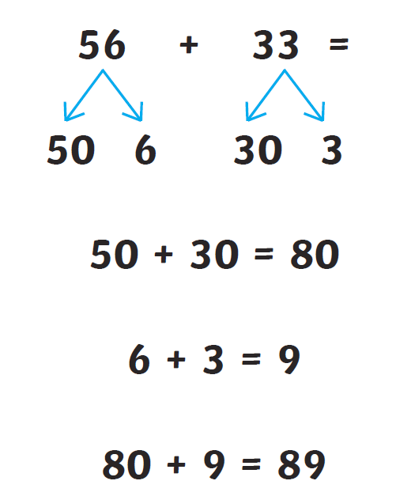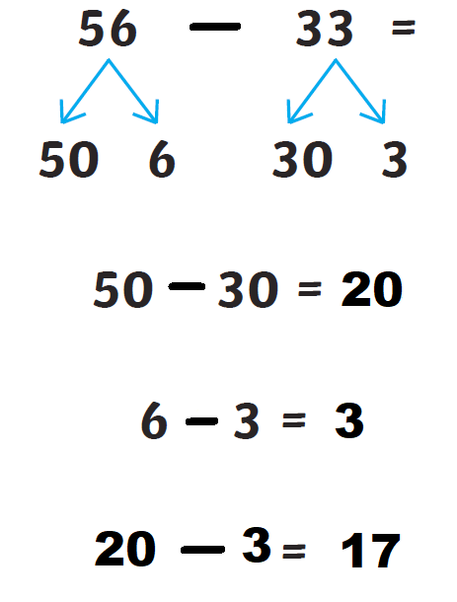
Complete the following addition and subtraction problems using the split strategy. Remember to show your working out.
- 37 + 42 = | - 45 + 63 = | - 72 + 36 =
- 62 + 46 = | - 66 + 45 = | - 74 + 35 =
- 89 – 26 = | - 35 – 11 = | - 93 – 73 =
- 65 – 44 = | - 78 – 34 = | - 99 – 22 =

2nd activity
Addition and subtraction word problems. Work out the answer to the following 3 questions and show your working.
- If the 22 students from 2/3M and the 23 students from 2/3 W were all in the same classroom together, how many students would there be in the classroom.

- I received 43 powerups from Term 1 and 65 powerups from Term 2. How many powerups do I have altogether?

- At Watson Road State School there are 64 students in the junior school and 76 in senior school. How many students are there altogether in the school?

3rd activity
5 x tables
When working out the 5 x tables we can the thumb and fingers on our hand to help us. For example, when working out 2 x 5 we can use both our hands to work out that 2 x 5 = 10
Complete the 5 x tables below
5 x 0 =
5 x 1 =
5 x 2 =
5 x 3 =
5 x 4 =
5 x 5 =
5 x 6 =
5 x 7 =
5 x 8 =
5 x 9 =
5 x 10 =
5 x 11 =
5 x 12 =

Friday
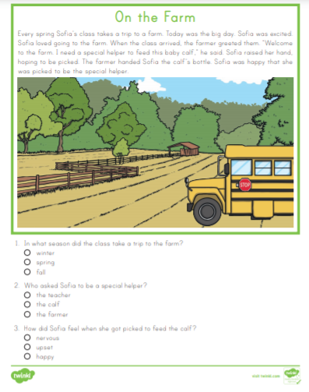
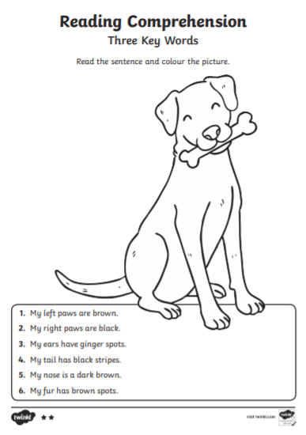
Drag the circle to choose you answer:
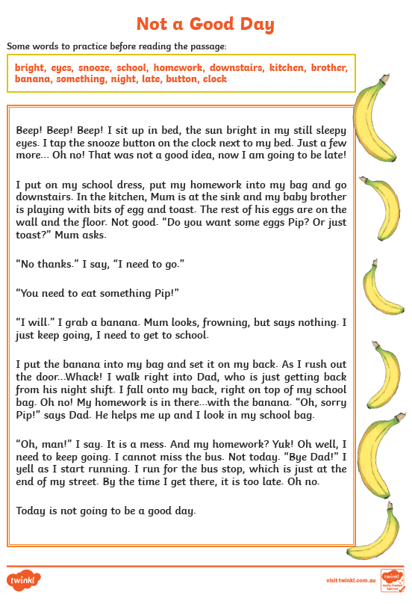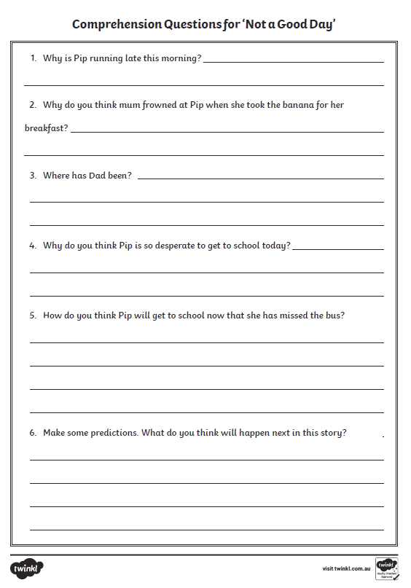
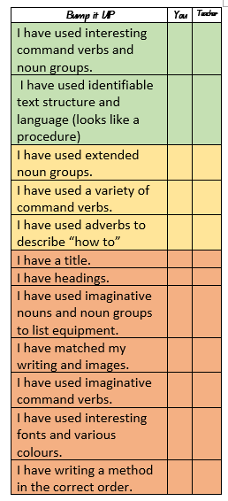
Create your own procedure. Check your work against the check list:
Title
Maths
1st activity
Split Strategy Addition and Subtractions 3 - digit numbers
The numbers are split into hundreds (100s), tens (10s) and ones (1s) and added or subtracted separately then they are put back together.
Example 1: Addition of 3 - digit numbers
237 + 142 =
200 + 100 = 300
30 + 40 = 70
7 + 2 = 9
300 + 70 + 9 = 379
237 + 142 = 379

Example 2: Subtraction of 3-digit numbers
289 – 126 =
200 – 100 = 100
80 – 20 = 60
9 – 6 = 3
100 + 60 + 3 = 163
289 – 126 = 163
Complete the following addition and subtraction problems using the split strategy. The first addition one (a) and the first subtraction one (g) were done in the examples. Remember to show your working out.
a. 237 + 142 = | b. 145 + 263 = | c. 372 + 436 =
d. 362 + 546 = | e.566 + 245 = | f. 274 + 135 =
g. 289 – 126 = | h. 235 – 111 = | i. 293 – 173 =
j. 365 – 244 = | k. 378 – 134 = | l. 499 – 322 =

2nd activity
Addition and subtraction word problems. Write the answers to the following 3 problems and show your working.
- If there are 142 students at Watson Road State School and 23 adults, how many people are at Watson Road State School altogether?

- If 131 students out of the 142 students at Watson Road State School were unable to come to school because of a COVID-19 lockdown, how many students would be at school?

- If I achieved 243 powerups in the 1st half the school year and 235 powerups in the 2nd half of the school year, how many powerups did I achieve altogether?

3rd activity
10 x tables
The number fact rule for the 10 x tables is add a zero. For example, if we multiply 4 x 10 or we have to do is add a zero to the 4, so 4 x 10 = 40
Complete the 10 x tables below
10 x 0 =
10 x 1 =
10 x 2 =
10 x 3 =
10 x 4 =
10 x 5 =
10 x 6 =
10 x 7 =
10 x 8 =
10 x 9 =
10 x 10 =
10 x 11 =
10 x 12 =

Art
Looking under! Minam Apang
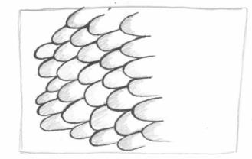 | 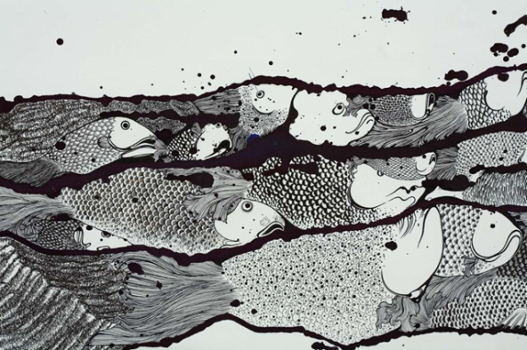  Minam Apang  The sleeping army may stir (detail), 2008  Minam Apang  India b.1980  The sleeping army may stir (detail) 2008  Ink and synthetic polymer paint on fabriano cold-pressed paper 70 x 240cm  Collection : Isabelle Levy and Geraldine Galateau, Paris Courtesy: The artist and Chatterjee & Lal, Mumbai | 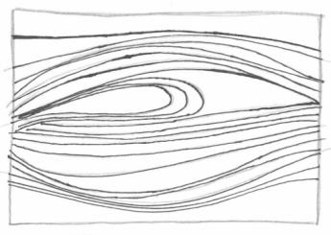
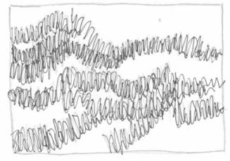 |  | 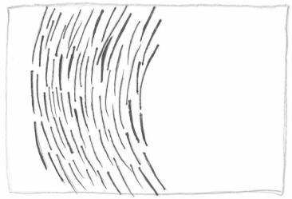
The patterns in the boxes are from this artwork.
Can you find the patterns on the fish?
Draw a line to connect the pattern to where you can see it in the artwork!


Draw a shape or a line and repeat it to create your own patterns.
The more times you repeat the shapes, the more detailed your pattern will be!

These fish are missing their scales!  Create patterns on their bodies. | 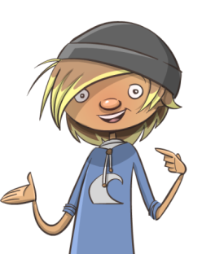  Add bright colours like fish under the sea.
