LUCKY LOTTERY WINNERS...
WIN AGAIN!
Reported by Susan Sharp, Media Correspondent, Ports Bay Mr and Mrs Mills of Smith Lane, Ports Bay,
could quite possibly be the luckiest couple in the country. William and Betty, who buy a lottery ticket once every month, have been celebrating for the second time in four years.
The couple scooped a huge $450 000 back in February 2012, having bought their ticket at the very last minute. Once they had recovered from the initial shock, they donated a large amount to several different charities, as well as making improvements to their home and treating

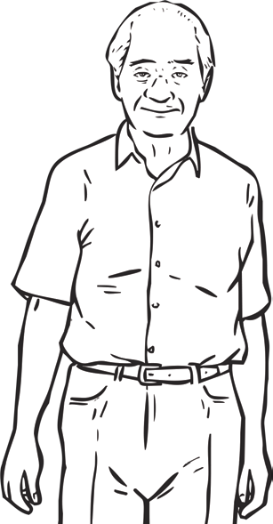
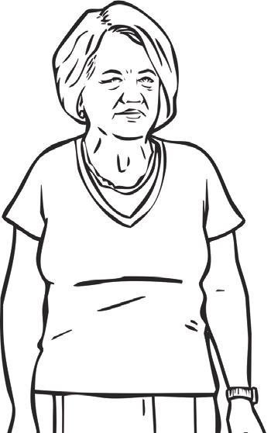
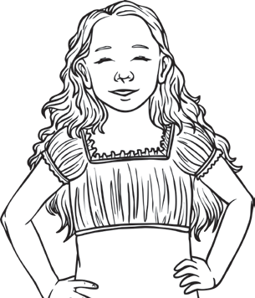
their family and friends to a few special holidays.
On the night of their most recent win, Mr and Mrs Mills had their granddaughter staying with them. Betty told us how it happened, “The lottery draw was on television and Alisha happened to be watching it. My husband and I were busy doing the dishes in the kitchen so she asked if she could check the numbers for us. The next thing we know, she’s screaming and shouting the house down! I thought she was joking.” The couple had five matching numbers, winning them a life-changing amount of $1.3 million. Mr Mills added, “We were all jumping around and dancing in the living room. We never believed it could happen again.” Alisha commented on the experience, “I
William and Betty Mills - are they the luckiest couple
in the country?

never knew my grandad could move like that!”
When asked about their secret for choosing winning numbers, Mr Mills explained, “We’ve always chosen numbers which mean something to us, like family birthdays or house numbers. My lucky number is 13.”
The two winners have revealed that they will be donating $1 million of their win to local, national and international charities. “They need the money more than we do,” stated Mrs Mills. “We’ll treat ourselves to a nice meal out somewhere and give the rest to the family. We have our health and happiness so what more could we ask for?”

Questions
- How often do William and Betty play the lottery?

- When did they win $450 000?

- Why do you think they donated some of their prize to charities?

- How do the couple choose their numbers?

- Write down two adjectives to describe William and Betty. Give reasons for your choices.

- How was their second win celebrated?

- What would you do with $1.3 million? Explain your reasons.





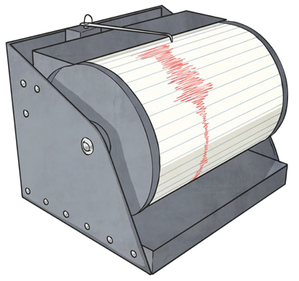

Earthquakes

The Earth’s Crust
The Earth’s crust and the top of the mantle have about twenty tectonic plates, which are like jigsaw puzzle pieces covering the Earth. These plates are always moving and bumping into each other. We call the edges of the plates ‘plate boundaries’, which are made up of faults. These faults are where most of the world’s earthquakes occur. As the plates move, the edges get stuck because they are not smooth, but the rest of the plate keeps moving. When the force is too much, it slips and bumps and that causes an earthquake.

Seismograph
A seismograph (say: size-mo-graf) is a special piece of equipment that records earthquakes. Seismometers are securely fastened to the Earth, so when the ground starts to shake, the instrument’s case moves too. What doesn’t move is a weight that hangs on a string inside the case. When there is an earthquake, the case shakes with the ground but the weight does not, and it draws a line to show how much the ground shook. Scientists use seismograms (graphs produced by the seismograph) to measure how big each earthquake is.
Interesting Fact
Six Italian scientists were convicted of manslaughter (killing someone without planning or being hateful) and sent to prison for not predicting (knowing it was coming and warning people) the 2009 L’Aquila earthquake in which 309 people died. They argued against their cases and won, so were eventually not sent to prison.

- Which layer of the Earth do the tectonic plates make up and how many are there?
They make up..

- What are plate boundaries?
Plate boundaries are…

- Where in the world do earthquakes take place?
Earthquakes take place…

- Describe what causes earthquakes.
Earthquakes are caused by…

- Which part of the seismograph moves? The case or the weight on a string?
The part of the seismograph that moves is …

My Narrative Checklist
- I have introduced characters/setting at the beginning of my story.
- I have used noun groups in my story
- I have used adjectives to describe my characters and setting.
- I have a complication in my story.
- I have a resolution to the complication in my story.
- I have included verbs and adverbs in my story.
- I have used capital letters and full stops.
- I have used full sentences that make sense.
- I am proud of my work.
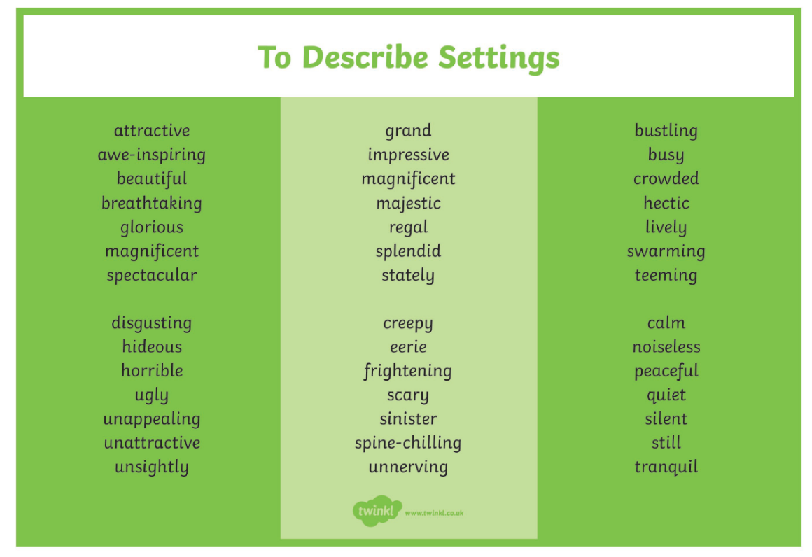

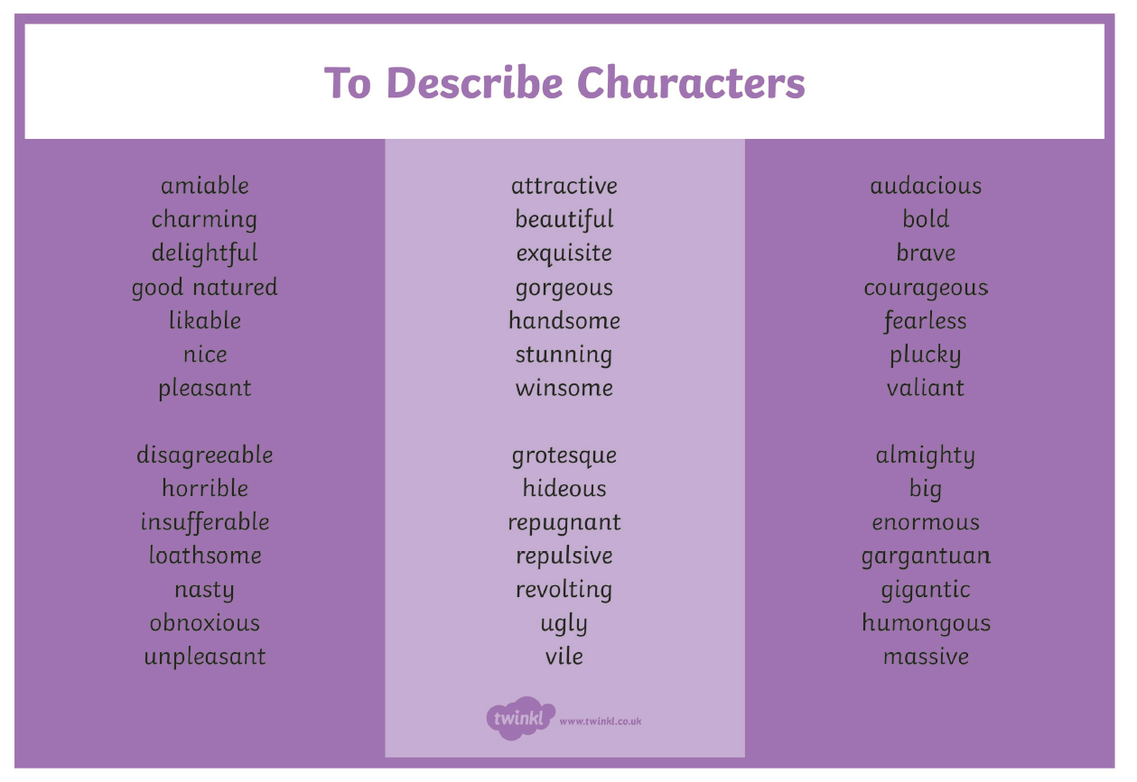
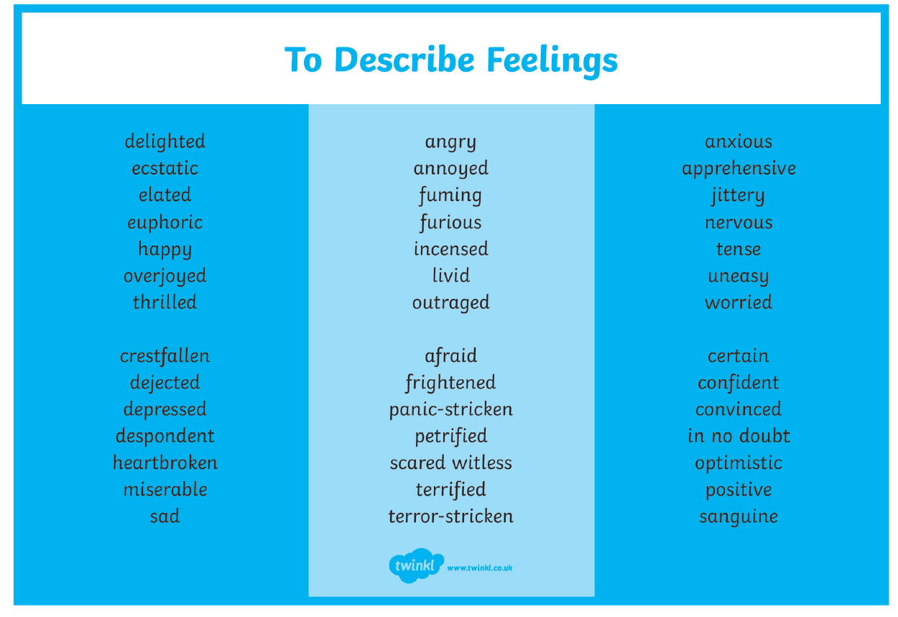
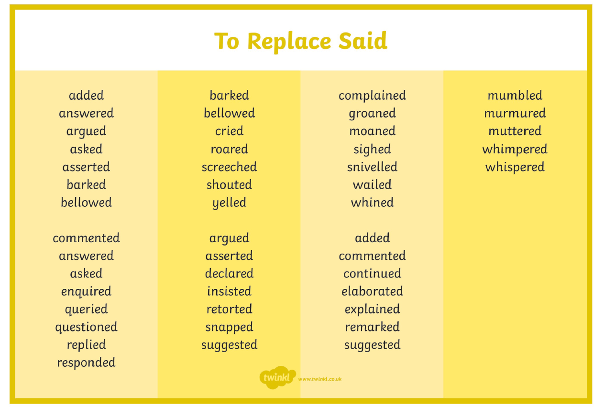

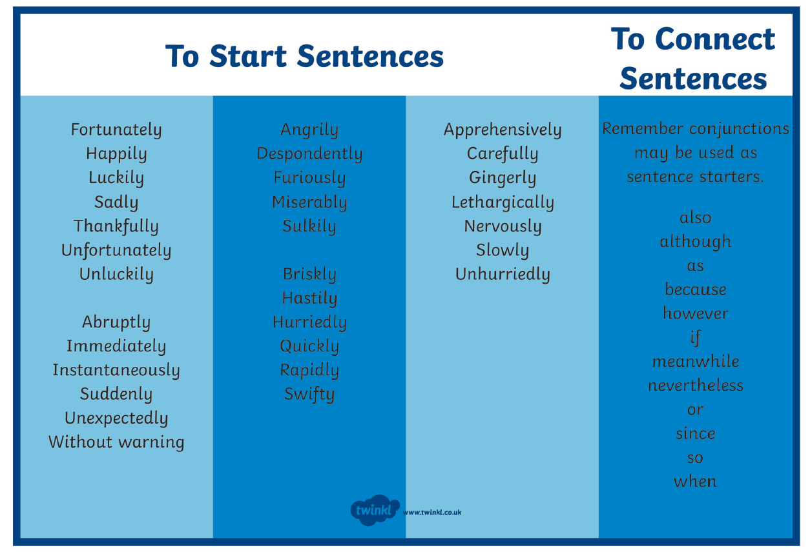

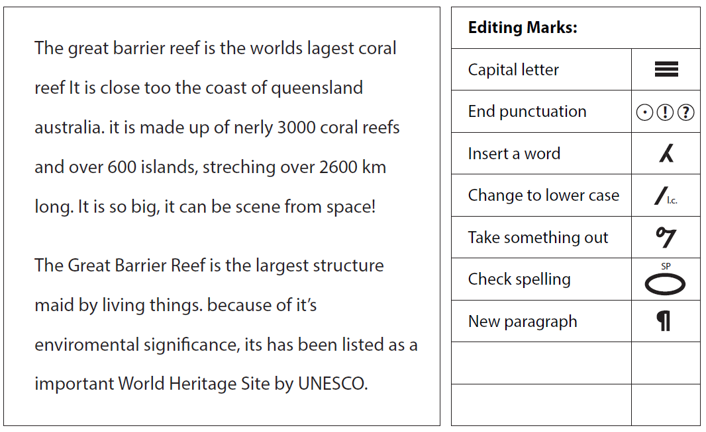

Nouns and Things

Often, the word ‘thing’ can make your writing dull and generic. Choosing better nouns could make your writing more specific. Below, think of three words that could match each of the following descriptions.

A mode of transport to get to school: A way of getting up a tall building: A type of food we like to eat: An item you like to play with: Utensils you can use to create art: An item you could use on a body of water: A way to stick two items together: Something you could look after: An item you could give a friend: An item you could put on your body:

Use 10 of the words you have come up with (one from each category) and write a paragraph that includes every word.

Identifying Descriptive Language – Nouns and Adjectives

- Common nouns are the names of people, places or things. Underline the common nouns in blue.
- Adjectives are words used to describe nouns.
- Underline the adjectives describing the common nouns in green.
- Remember, not every noun will have an adjective connected to it.

The Cat and the Whale
Many years ago, some ferocious pirates sailed the seas. One of the pirates decided to bring his adventurous cat along for the journey.
A terrible storm overturned the unlucky ship. The doomed pirates fell into the rocky ocean. The fearful cat thought that he would drown. A giant whale appeared and bravely rescued the cat.
The waterlogged cat and the heroic whale arrived at a tropical island. The cat jumped excitedly onto the golden sand. The curious whale asked the cat, “Do you know this island?” The confident cat replied, “Yes! The king of this beautiful island is my best friend, and I am a famous prince!”
The clever whale knew that this was a deserted island. He said to the cat, “You’re a famous prince? How extraordinary! Well, now you can be king!”
The confused cat answered, “But how can I be king?”
The whale laughed. “Easy! There’s no other living creature on this island. There is no one else who can be king!”

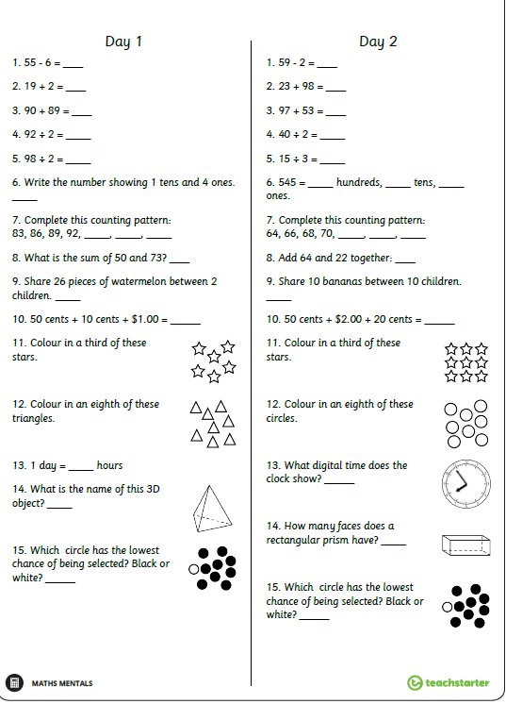

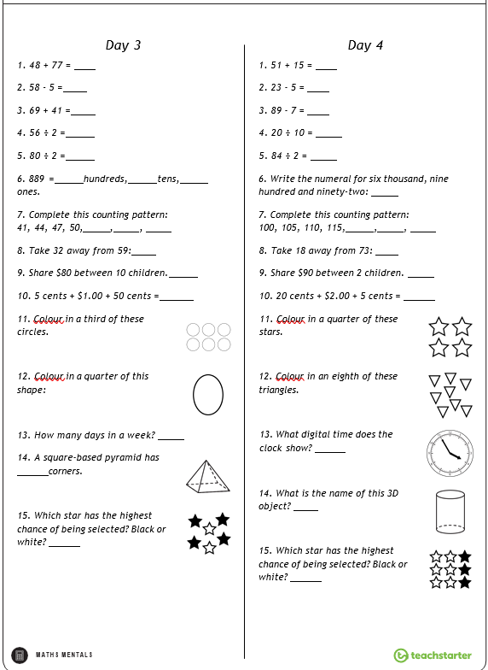

MONEY MATTERS!

Find a shopping receipt or catalogue at home.
• Pick 3 items you would like and work out how much it would cost to buy them all.
• Find 3 items you could buy for $10.00.
• What are the cheapest and most expensive items?

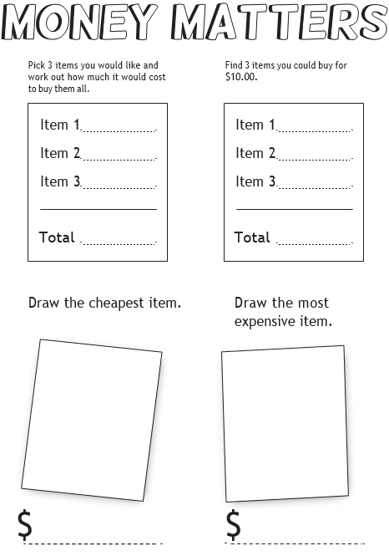





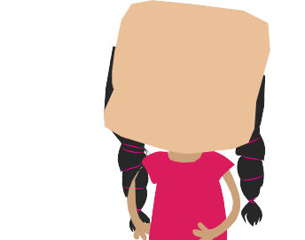


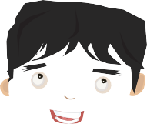



pRoBlEm sOlViNg

Molly is moving around the furniture in her bedroom.
The bed must be placed under the window, but away from the door.
The desk must be against the wall, but away from the window. The lamp must be next to the desk, but away from the bed.
Draw a plan of what Molly’s bedroom could look like.

Open-ended Maths Task Cards




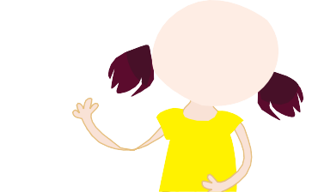







pRoBlEm sOlViNg

Katie’s class are going on a school outing. There are 32 students in her class.
The students must be placed in small groups during the outing.
There must be no less than 2 and no more than 12 students in each group.
How many groups could there be? How many students would be in each group?
List some possibilities.-ended Maths Task Cards




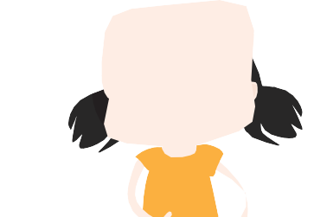



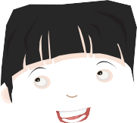



pRoBlEm sOlViNg

Mei is playing a lucky numbers game. She must pick three numbers out of a bag.
The numbers in the bag are: 12, 8, 15, 2, 11 and 9.
Mei will win a prize if the three numbers add up to a number less than 20; if the three numbers add up to a multiple of five; or if the three numbers add up to a number greater than 30.
List some winning combinations of numbers.

Open-ended Maths Task Cards

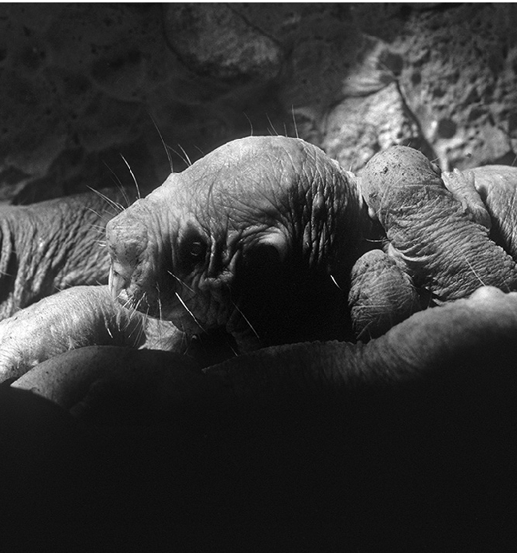
2
Date:
1
Date:
Litter size varies greatly in mammals. The average litter of naked mole rats is about 15 pups, but some mothers can have a whopping 30 pups in one litter! Among mammals, that is one of the largest litters of all.
DIET
Naked mole rats eat tubers, which are the underground parts of plants. Sometimes, these tubers are as big as pumpkins. As well as being a food source, the tubers ‘hydrate’ the mole
rats, which means they provide the rats with water.
Neil Bromhall/Shutterstock.com

1) 2 × 1 =
2) 7 × 2 =
3) 4 × 3 =
4) 5 × 1 =
5) 3 × 5 =
6) 2 × 3 =
7) 1 × 1 =
8) 3 × 2 =
9) 5 × 10 =
10) 6 × 5 =
11) 3 × 3 =
12) 4 × 5 =
13) 12 × 3 =
14) 6 × 1 =
15) 7 × 3 =
16) 1 × 5 =
17) 12 × 2 =
18) 11 × 5 =
19) 2 × 2 =
20) 9 × 2 =
1) 10 × 10 =
Score:
Time:
2) 9 × 10 =
3) 4 × 1 =
4) 9 × 2 =
5) 1 × 2 =
6) 4 × 5 =
7) 2 × 3 =
8) 10 × 2 =
9) 9 × 1 =
10) 12 × 3 =
11) 6 × 2 =
12) 4 × 3 =
13) 5 × 1 =
14) 7 × 1 =
15) 7 × 10 =
16) 0 × 3 =
17) 11 × 1 =
18) 2 × 5 =
19) 5 × 2 =
20) 10 × 5 =
Score:
Time:

4
Date:
3
Date:

1) 0 × 1 =
2) 10 × 2 =
3) 6 × 5 =
4) 9 × 5 =
5) 8 × 3 =
6) 1 × 2 =
7) 2 × 10 =
8) 10 × 1 =
9) 9 × 3 =
10) 4 × 1 =
11) 10 × 10 =
12) 7 × 5 =
13) 9 × 2 =
14) 9 × 10 =
15) 10 × 3 =
16) 0 × 5 =
17) 6 × 3 =
18) 12 × 1 =
19) 4 × 3 =
20) 8 × 2 =
1) 9 × 10 =
Score:
Time:
2) 10 × 1 =
3) 10 × 3 =
4) 6 × 2 =
5) 1 × 3 =
6) 6 × 1 =
7) 1 × 1 =
8) 8 × 1 =
9) 4 × 5 =
10) 4 × 1 =
11) 3 × 1 =
12) 11 × 10 =
13) 6 × 5 =
14) 2 × 10 =
15) 11 × 2 =
16) 5 × 10 =
17) 6 × 3 =
18) 9 × 2 =
19) 0 × 1 =
20) 6 × 10 =
Score:
Time:


ART - Design your artwork
Use one of the following shape templates to draw your animal sculpture. |  |  | Artworks don’t have to be realistic.
This design uses the oval shape. Your design can extend outside the template.
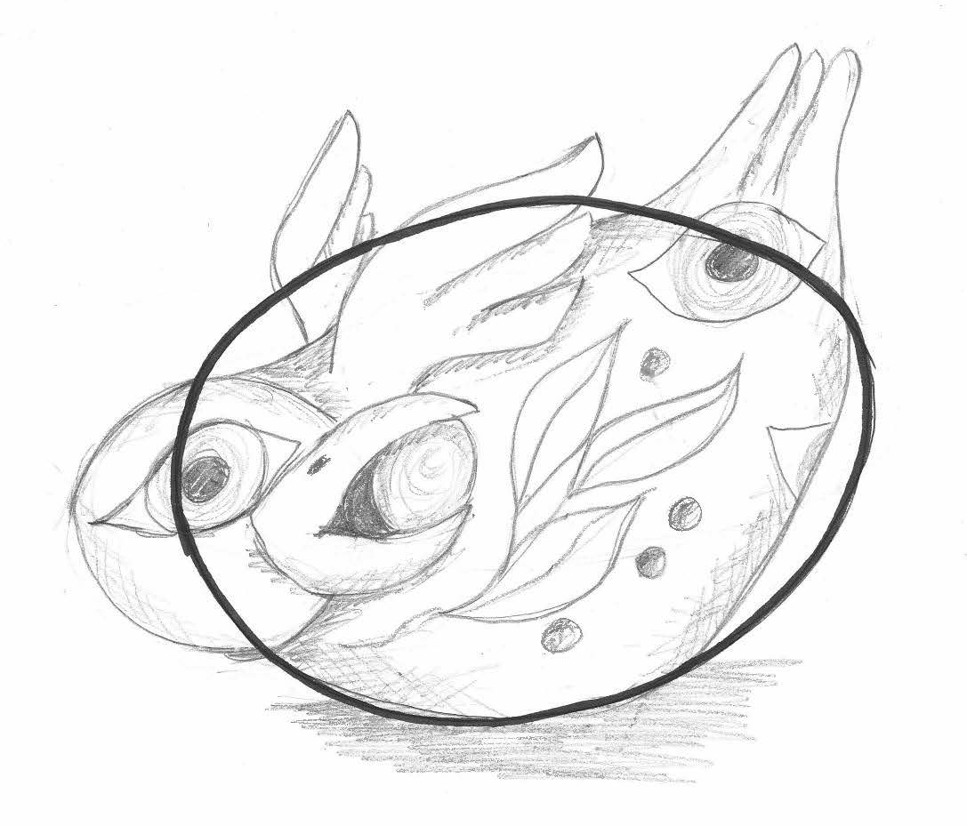 |  | Remember, different shapes communicate different personalities.  You can turn the shapes any way you like!
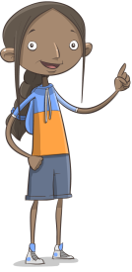
It’s a good idea to think about what you could use to decorate your sculpture once it is dry. This could be paint, collage or found materials.

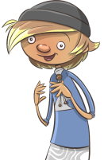
What other materials (media) will you use to decorate your sculpture?
Explain your choices.

Shape template
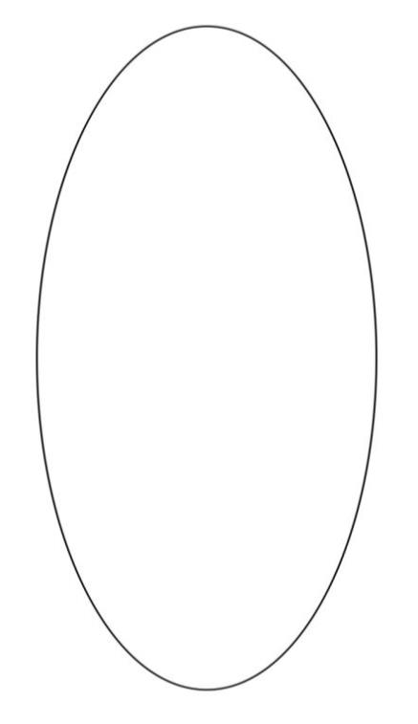

Shape template

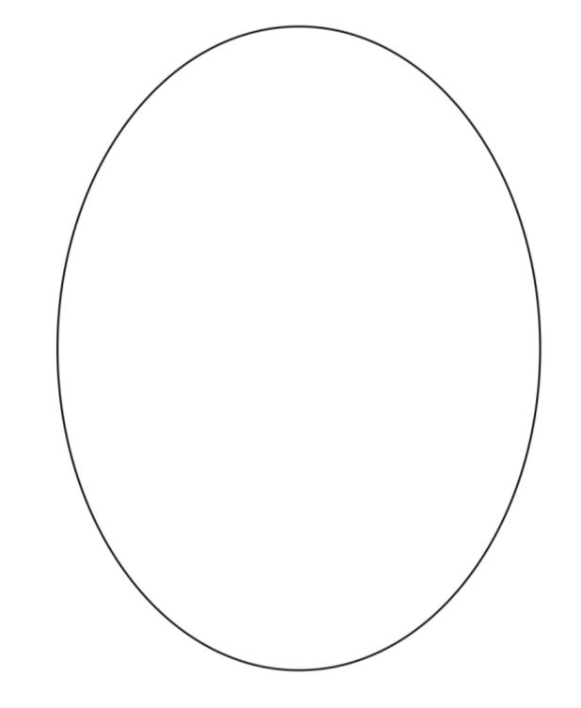
Shape template

Shape template

Practice your signing and finger-spelling (Greet your family in sign. Ask how they are, what they are doing today. Teach them finger-spelling by playing Hangman)
Plan your day at home. Explain what you will be doing today to your family using signing and finger-spelling.

TIME | ACTIVITY

Have your family ask you for the time throughout the day. Reply in sign.

