The Fable of the Two Doves
Long ago, there lived a wealthy scholar and his daughter, Koongse. The scholar had an assistant working for him, whose name was Chang. Chang and Koong-se were very much in love. However, Chang was seen as just a poor assistant so a relationship between the two was not allowed. Instead, every night, the couple secretly meet under the stars.


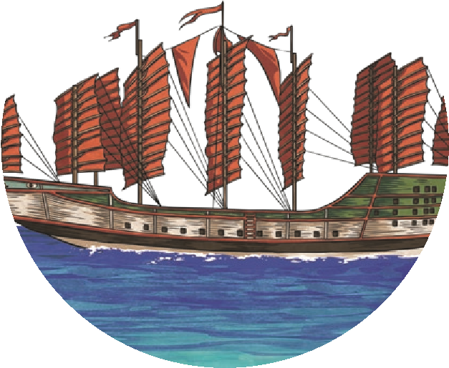
One night, the scholar noticed that his daughter was missing and sent someone to follow her. When he heard that she was with Chang, the scholar was furious. He immediately fired Chang and ordered that a high fence should be built around the palace. He locked Koong-se in her room and stopped anyone from visiting her. Then, he arranged for his daughter to marry a rich duke. Because she did not want to be locked away, Koong-se agreed to the marriage. Secretly, she wished that Chang would come and help her to escape but it was agreed that Koong-se and the duke would get married on the day that the first blossom fell from the willow tree.
On the day of the wedding, Chang disguised himself as a servant and crept past the palace guards. Koong-se was so happy to see him! He quickly explained his plan to escape. They began to run down the palace corridors and they did not stop until they were through the palace gates.
One of the guests recognised the couple and shouted that the bride was trying to escape. The wealthy scholar chased after them but it was too late. Chang and Koong-se had already escaped in the duke’s ship. Not wanting to be caught,
they sailed quickly away from the palace. Eventually, they came across a
beautiful deserted island, which was covered with tall palm trees and large ferns. They landed and began to build a shelter.
The couple lived together for many happy years until, one day, the duke heard about two people who had been spotted living on a small island. Desperate for revenge, the duke sent his soldiers to find them. A few days later, the couple were captured.

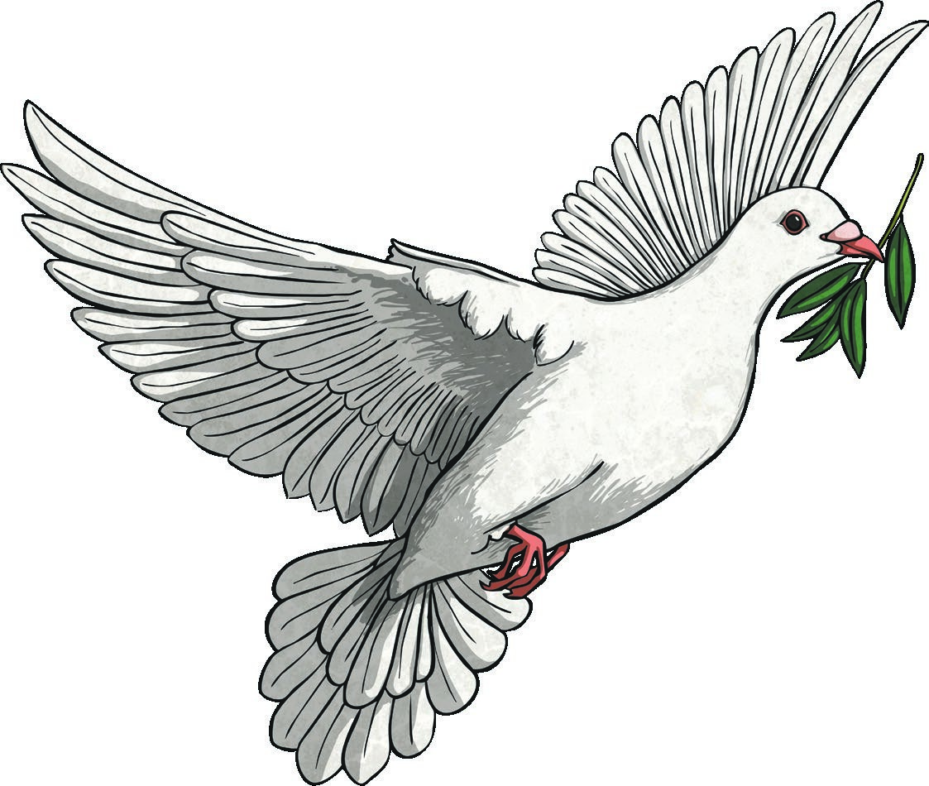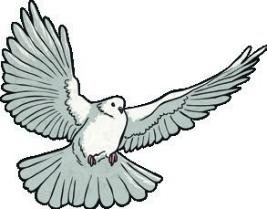
Luckily for Koong-se and Chang, the gods had been watching them. They were
so moved by their story that they transformed Koong-se and Chang into a pair
of doves. The couple flew away from the guards and happily spent the rest of
their lives together.
The Fable of the Two Doves

Questions
- What was the first thing that Koong-se and Chang did when they landed on the island? Tick one.
turned into doves got married caught some fish built a shelter
- Number the events from 1-4 to show the order that they happened in.
Chang and Koong-se turn into doves.
Chang and Koong-se find an island.
The scholar fires Chang.
The soldiers capture Chang and Koong-se.
- Who is Koong-se supposed to marry when the first blossom falls from the willow tree? Tick one.
Chang the duke the scholar a servant
- Who transformed Koong-se and Chang into a pair of doves? Tick one.
the gods Koong-se the scholar the duke
- Why was Koong-se not allowed to be in a relationship with Chang?

- What did Chang disguise himself as to get past the guards?

- Do you think that Koong-se and Chang were happy to be turned into doves? Explain your answer.

Answers
- What was the first thing that Koong-se and Chang did when they landed on the island? Tick one.
turned into doves got married caught some fish built a shelter
- Number the events from 1-4 to show the order that they happened in.
4 Chang and Koong-se turn into doves.
  - Chang and Koong-se find an island.
1 The scholar fires Chang.
  - The soldiers capture Chang and Koong-se.
- Who is Koong-se supposed to marry when the first blossom falls from the willow tree? Tick one.
Chang the duke the scholar a servant
- Who transformed Koong-se and Chang into a pair of doves? Tick one.
the gods Koong-se the scholar the duke
- Why was Koong-se not allowed to be in a relationship with Chang?
Koong-se was not allowed to be in a relationship with Chang because he was just seen as a poor assistant.

- What did Chang disguise himself as to get past the guards?
Chang disguised himself as a servant so that he could get past the guards.
- Do you think that Koong-se and Chang were happy to be turned into doves? Explain your answer.
Pupils’ own responses, such as: I think that Koong-se and Chang were happy to be turned into doves because now they can live together forever and just fly to a new place if the duke finds them again.

The Fable of the Two Doves
Long ago, in ancient China, there lived a wealthy scholar and his beautiful, intelligent daughter, Koong-se. The scholar employed an assistant accountant named Chang. Chang and Koong-se had many interests in common and they
were very much in love. However, Chang was seen as just a poor assistant so a relationship between the two was forbidden. Because of this, whenever the moon hung high in the sky, the couple would secretly meet.
One night, the scholar noticed that his daughter was missing and sent his guard to follow her. When he heard that she was with the assistant, the scholar was furious. He immediately fired
Chang and ordered that a high fence should be built around his palace to keep Chang and Koong-se apart. He locked Koong-se in her room and refused to allow her any visitors. The scholar then arranged for Koong-se to marry a rich and powerful duke. Koong-se was so lonely and she was desperate to leave the prison that her room had become so she reluctantly agreed to the marriage.
Secretly, Koong-se wished that Chang would run away with her but, unfortunately, he never appeared and it was agreed that Koong-se and the duke would be married on the day that the first blossom fell from the willow tree.
On the day of the wedding, Chang disguised himself as a servant and slipped past the palace guards. Koong-
se was so happy to see him that she forgot the danger that they were now both in. Chang quickly explained his escape plan and the pair began to run down the palace corridors, which were already swarming with wedding guests,
and out of the silver gates.


One of the guests recognised the couple and raised the alarm that the bride was trying to escape. The scholar chased after them but it was too late. Chang and Koong-se had already escaped in the duke’s ship. Aided by the strong wind, they sailed towards the horizon and away from the palace. After several days, the pair came across a beautiful deserted island which was covered with large palm trees and leafy ferns. They landed and began to build a shelter.

The couple, safely together, lived on the island for many happy years until,
one day, an explorer told the duke about some people he had seen on a remote
island. Desperate for revenge, the duke sent his soldiers to the island. Within
days, the couple were captured.
Luckily for Koong-se and Chang, the gods had been looking down at them from
high in the heavens. Deeply moved by their story, the gods transformed Koong-
se and Chang into a pair of doves. The couple were now able to live the rest of
their lives free and together.
The Fable of the Two Doves

Questions
- Before he was fired, what was Chang’s job? Tick one.
assistant accountant chief accountant chef to the scholar assistant chef to the scholar
- What helped the couple to sail away quickly? Tick one.
the ship belonged to the duke the wind was strong the island was close the sea’s current was strong
- Number the events from 1-4 to show the order that they happened in.
Chang disguises himself as a servant.
Koong-se agrees to marry the duke. The couple steal the duke’s ship.
The gods choose to help the couple.
- Draw four lines to complete the sentences.
Koong-se felt forced to marry
the couple.
the duke.
by the gods.
the palace guards.
The couple were transformed
The duke sent his soldiers to find
Chang managed to slip past
- Look at the paragraph beginning: On the day of the wedding...
Find and copy one word which shows that there were lots of people in the palace.

- How long were the couple living on the island for before they were discovered?

- Describe the scholar’s character. Explain your answer.

- Do you think that it was fair for Koong-se’s father to lock her in her room? Explain your answer.

Answers
- Before he was fired, what was Chang’s job? Tick one.
assistant accountant chief accountant chef to the scholar assistant chef to the scholar
- What helped the couple to sail away quickly? Tick one.
the ship belonged to the duke the wind was strong the island was close the sea’s current was strong
- Number the events from 1-4 to show the order that they happened in.
2 Chang disguises himself as a servant.
1 Koong-se agrees to marry the duke. 3 The couple steal the duke’s ship.
4 The gods choose to help the couple.
4
.
Draw four lines to complete the sentences.
Koong-se felt forced to marry
the couple.
The couple were transformed
the duke.
The duke sent his soldiers to find
by the gods.
Chang managed to slip past
the palace guards.
- Look at the paragraph beginning: On the day of the wedding...
Find and copy one word which shows that there were lots of people in the palace swarming
- How long were the couple living on the island for before they were discovered?
The couple were living on the island for many years before they were discovered.
- Describe the scholar’s character. Explain your answer.
Pupils’ own responses, such as: The scholar is not very nice because he refuses to let his daughter visit Chang. He is also very powerful because he can arrange a wedding with a rich duke.
- Do you think that it was fair for Koong-se’s father to lock her in her room? Explain your answer.
Pupils’ own responses, such as: I do not think that it was fair because Koong-se did not do anything wrong and he didn’t let her have any visitors. He made her feel really lonely, which was unfair.

The Fable of the Two Doves
Long ago, in ancient China, there lived a wealthy scholar. He had a beautiful and intelligent daughter, whose name was Koong-se. Working for the scholar was an assistant accountant named Chang. He and Koong-se had many interests
in common and they were very much in love. However, as Koong-se was the daughter of a scholar and Chang was just seen as a poor assistant, a relationship between the two was forbidden. As a result, whenever the moon hung high in the sky, the couple would meet in secret.
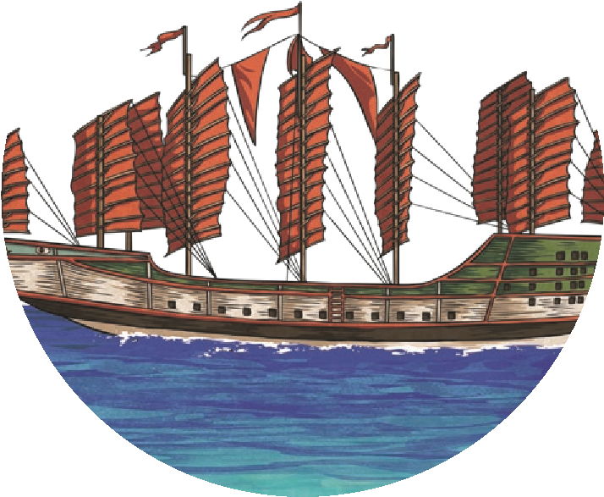


One night, the scholar noticed that Koong-se was missing and sent his guard, Jian, to follow her. Upon hearing that she was with Chang, the scholar was furious. He immediately fired Chang and ordered that a high fence should be built around his palace to keep the lovers apart. He locked Koong-se in her room and forbade anyone to visit her unless they had sought his permission. The scholar then arranged a marriage between Koong-se and a powerful duke. Koong-se was so lonely (having been locked in her room for weeks) that she reluctantly agreed to the marriage. Secretly, she wished that Chang would appear and take her away. Unfortunately, with no sign of Chang, it was agreed that Koong-se and the wealthy duke would be married on the day that the first blossom fell from the willow tree.
On the day of the wedding, Chang disguised himself as a servant and managed to slip past the palace guards. Koong-se was delighted to see him and threw her arms around him. Chang quickly explained his escape plan and the pair began to run down the palace corridors, through the garden (which was already filling with wedding guests) and out of the silver gates.
One of the arriving guests recognised the fleeing couple and raised the alarm that the bride was trying to escape. The scholar flew into a rage and chased after the couple but it was too late. Chang and Koong-se had already boarded the duke’s ship. Aided by the persistent wind, they sailed towards the horizon.
After several days, the pair came across a beautiful, secluded island which was filled with palm trees and colourful vegetation. They landed the ship and began to
build a shelter.

The couple, safely together, lived on the island for
many happy years until, one day, the duke learned
of their refuge. Hungry for revenge, he sent his
soldiers to the island. Outnumbered, the couple
were swiftly captured.
From high in the heavens, the gods gazed upon
the unhappy lovers. They had been watching
them for a while and were so moved by their
story that they transformed Koong-se and
Chang into a pair of doves. The couple were now
able to live the rest of their lives together in freedom.
The Fable of the Two Doves

Questions
- Number the events from 1-4 to show the order that they happened in.
Chang disguises himself as a servant.
Koong-se and Chang are captured.
Chang helps Koong-se to escape.
Chang and Koong-se meet under the moon.
- Who captured Koong-se and Chang on the island? Tick one.
the duke the duke’s soldiers the scholar the gods
- How did Koong-se and Chang get to the island?

- Look at the paragraph beginning: One of the arriving guests... Find and copy one word which means ‘on its own’.

- Who alerted the scholar to the fact that Koong-se was escaping?

- Compare Koong-se and Chang at the beginning of the story to the end of the story.

- Do you think that this story has a happy ending? Explain your answer.

- He locked Koong-se in her room and forbade anyone to visit her unless they had sought his permission.
Do you think that the way the scholar reacted was fair? Explain your answer.

Answers
- Number the events from 1-4 to show the order that they happened in.
  - Chang disguises himself as a servant.
4 Koong-se and Chang are captured.
  - Chang helps Koong-se to escape.
1 Chang and Koong-se meet under the moon.
- Who captured Koong-se and Chang on the island? Tick one.
the duke the duke’s soldiers the scholar the gods
- How did Koong-se and Chang get to the island?
Koong-se and Chang got the island using the duke’s ship.
- Look at the paragraph beginning: One of the arriving guests... Find and copy one word which means ‘on its own’.
secluded
- Who alerted the scholar to the fact that Koong-se was escaping?
One of the guests alerted the scholar that Koong-se was escaping.
- Compare Koong-se and Chang at the beginning of the story to the end of the story. Pupils’ own responses provided that a reasonable comparison is made, such as: At the beginning of the story, Koong-se and Chang can only meet in secret and nobody knows about their relationship. At the end of the story, they can spend the rest of their lives together but they are now doves instead of humans.
- Do you think that this story has a happy ending? Explain your answer.
Pupils’ own responses, such as: I think that this story does have a happy ending because Koong-se and Chang do not remain captured and they are free to live the rest of their lives together.
- He locked Koong-se in her room and forbade anyone to visit her unless they had sought his permission.
Do you think that the way the scholar reacted was fair? Explain your answer.
Pupils’ own responses, such as: I do not think that the scholar was fair to lock Koongse in her room because all that she had done was go to see Chang. Chang wasn’t a bad person; the scholar just didn’t like him.

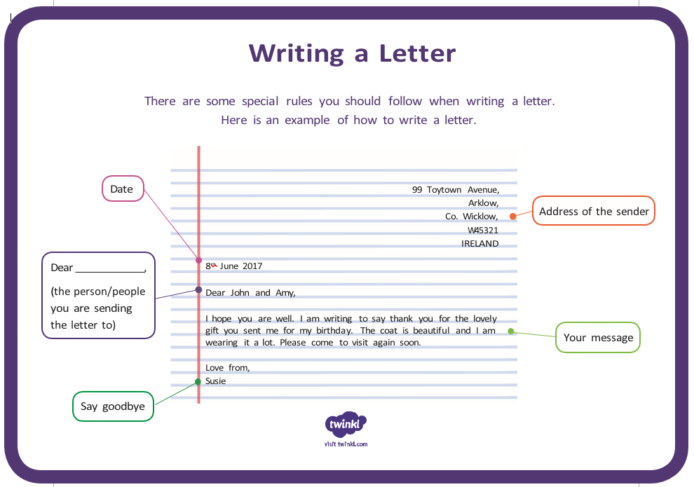

Father’s Day
For most people, Father’s Day is a happy day, but it has a sad start to its history. On 5th July 1908, a memorial event was held to honour the lives of 362 men who had died in an explosion at the Fairmont Coal Company mines in West Virginia, USA. Many men who died were father figures: fathers, stepfathers, uncles, grandfathers, godfathers and carers.
One year later, a young woman named Sonora Smart Dodd heard a church sermon about Mother’s Day. Sonora’s mother had died when she was 10 years old and she was one of six children who had been raised by her father. She decided to try to gather support to start an official national day to honour fathers.
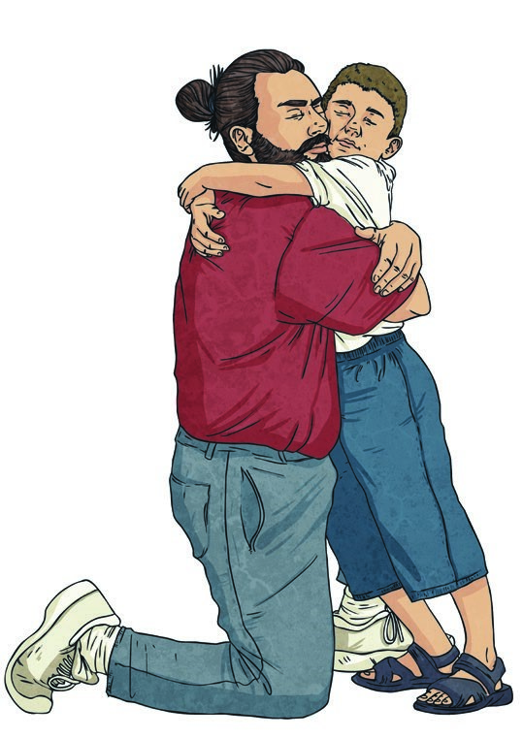
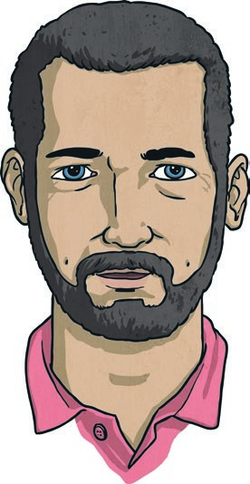
Sonora talked to a number of groups about her plan. She talked to churches, the YMCA, shopkeepers, and the government. Finally, 19th June 1910 was chosen by Washington State to be the world’s first official Father’s Day. Other countries chose their own official days to celebrate Fathers’ Day. Australia celebrates Father’s Day on the first Sunday in September each year.
Did You Know?
- In the UK, Father’s Day is celebrated each year on the third Sunday of June.
- Sonora Dodd originally wanted Father’s Day to be celebrated on the 5th of May, which was her father’s birthday.
People in Australia celebrate Father’s Day in many different ways. It is a good time to show appreciation to any man who acts like a father. Some of the most common ways to do this might be to spend quality time with that person, to give a thoughtful gift that suits him or to perform a thoughtful gesture that could brighten up his day.

Father’s Day Questions
- Why was a memorial service given in West Virginia in July 1908?

- Who was Sonora Smart Dodd?

- Who did Sonora try to get support from?

- In what year was the first official Father’s Day in the world celebrated?

- Other than biological fathers, who else might be celebrated on this day?

- What does ‘role of a father’ mean?

- How will you celebrate Father’s Day?

Father’s Day Answers
- Why was a memorial service given in West Virginia in July 1908?
The memorial service was given in West Virginia to honour the lives of 362 men who had perished in an explosion at the Fairmont Coal Company mines.
- Who was Sonora Smart Dodd?
Sonora Dodd was a young woman who tried to establish a national day to celebrate fathers.
- Who did Sonora try to get support from?
Sonora tried to get support from churches, the YMCA, shopkeepers and the government.
- In what year was the first official Father’s Day in the world celebrated? The first Father’s Day was celebrated in 1910.
- Other than biological fathers, who else might be celebrated on this day?
Any man who plays the role of a father in someone’s life might be celebrated on this day (e.g. stepfathers, uncles, grandfathers, godfathers, carers, friends, mentors).
- What does ‘role of a father’ mean?
To play the role of father means that a person acts like a dad/ father to somebody who isn’t necessarily their child.
- How will you celebrate Father’s Day?
Various answers.

Father’s Day
Although it is seen around the world today as a day of celebration, Father’s Day actually has its roots in a tragedy. On 5th July 1908, a memorial event was held to honour the lives of 362 men who had perished in an explosion at the Fairmont Coal Company mines in West Virginia, USA. A great number of the men who died were father figures in their communities.
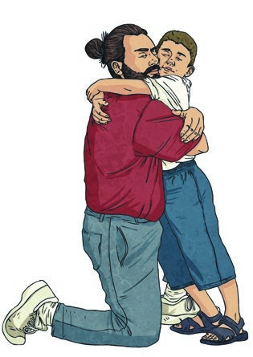

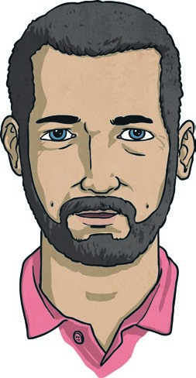
The following year, a young woman named Sonora Smart Dodd was sitting in church and heard a sermon about Mother’s Day. Sonora’s mother had died when she was 10 years old, and she was one of six children who had been raised by her father. She appreciated all the love her father had given to her and all the hard work he had done in raising her, so she decided to try to garner support to start an official national day to honour fathers.
Did You Know?
- In the UK, Father’s Day is celebrated each year on the third Sunday of June.
- Sonora Dodd originally wanted Father’s Day to be celebrated on the 5th of May, which was her father’s birthday.
She successfully petitioned a number of groups, including churches, the YMCA, shopkeepers, and the government. Finally, 19th June 1910 was chosen by Washington State to be the first official Father’s Day in the world. Since then, countries around the world have chosen their own official days to celebrate Fathers’ Day. Australia celebrates Father’s Day on the first Sunday of September each year.
There are no set traditions for how people celebrate Father’s Day in Australia because no two people are exactly the same. People have different ways of showing their appreciation, not only to their biological fathers, but to any man who plays the role of a father in their lives. The most common ways to do this would be to spend quality time with that person, to give a thoughtful gift that suits him or to perform a thoughtful gesture that will brighten up his day.

Father’s Day Questions
- What happened on 5th July 1908 in West Virginia?

- Why do you think Sonora Dodd was so determined to have a national day just for fathers?

- What does the word ‘garner’ mean?

- When will Father’s Day be celebrated in Australia this year?

- Other than biological fathers, who else might be celebrated on this day?

- What does ‘appreciate’ mean?

- How will you celebrate Father’s Day?

Father’s Day Answers
- What happened on 5th July 1908 in West Virginia?
A memorial event was held to honour the lives of 362 men who had perished in an explosion at the Fairmont Coal Company mines.
- Why do you think Sonora Dodd was so determined to have a national day just for fathers? Sonora Dodd was determined because she wanted to show appreciation for her father, who had raised her and her siblings on his own.
- What does the word ‘garner’ mean? Garner means to gather or collect
- When will Father’s Day be celebrated in Australia this year?
Father’s Day is celebrated on the first Sunday of September (3rd September 2017; 2nd September 2018; 1st September 2019; 6th September 2020, etc.)
- Other than biological fathers, who else might be celebrated on this day?
Any man who plays the role of a father in someone’s life (e.g. stepfathers, uncles, grandfathers, godfathers, carers, friends, mentors).
- What does ‘appreciate’ mean?
Appreciate means to feel grateful or thankful for something or someone.
- How will you celebrate Father’s Day?
Various answers.

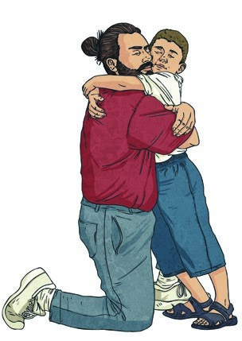
Father’s Day
While it’s now seen around the world as a day of celebration, Father’s Day has its roots in a calamity. On 5th July 1908, a memorial event was held to honour the lives of 362 men, who had perished in a devastating blast at the Fairmont Coal Company mines in West Virginia, USA. Many of the men who died were father figures in their communities.
Less than 12 months later, a young woman named Sonora Smart Dodd witnessed a church sermon about Mother’s Day, which sparked her imagination. Sonora’s mother had passed away when she was 10 years old and she was one of six children who had been raised by her father. She appreciated the complexities of the job her father had in raising her. She decided to try to garner support to start an official national day to honour fathers.
Did You Know?
- In the UK, Father’s Day is celebrated each year on the third Sunday of June.
- Sonora Dodd originally wanted Father’s Day to be celebrated on the 5th of May, which was her father’s birthday.
Sonora Dodd successfully petitioned a number of groups, including churches, the YMCA, shopkeepers, and the government. Finally, 19th June 1910 was chosen by Washington State to be the first official Father’s Day in the world. Since then, countries around the world have chosen their own official days to celebrate Fathers’ Day. Australia celebrates Father’s Day annually on the first Sunday of September.
There are no hard-and-fast traditions on how people celebrate Father’s Day in Australia because no two people are identical. People have diverse ways of showing their appreciation, not only to their biological fathers, but to any man who plays the role of a father in their lives. The most common ways to do this would be to spend quality time with that person, to give a thoughtful gift that suits him, or to perform a thoughtful gesture that will brighten up his day.

Father’s Day Questions
- What does ‘calamity’ mean?

- What happened on 5th July 1908 in West Virginia?

- Why do you think Sonora Dodd was so determined to have a national day just for fathers?

- What does the word ‘garner’ mean?

- How could you work out the date of Father’s Day next year?

- Other than biological fathers, who else might be celebrated on this day?

- What does ‘hard-and-fast’ mean?

- How will you celebrate Father’s Day?

Father’s Day Answers
- What does ‘calamity’ mean?
Calamity means tragedy/disaster/a damaging or distressing event.
- What happened on 5th July 1908 in West Virginia?
A memorial event was held to honour the lives of 362 men who had perished in an explosion at the Fairmont Coal Company mines.
- Why do you think Sonora Dodd was so determined to have a national day just for fathers? Sonora Dood was so determined to have a national day just for fathers because her mother had died and she wanted to show appreciation for her father, who had raised her and her siblings on his own.
- What does the word ‘garner’ mean? Garner means to gather or collect
- How could you work out the date of Father’s Day next year?
Father’s Day is on the first Sunday of September (3rd September 2017; 2nd September 2018; 1st September 2019; 6th September 2020).
- Other than biological fathers, who else might be celebrated on this day?
Any man who plays the role of a father in someone’s life might be celebrated on this day (e.g. stepfathers, uncles, grandfathers, godfathers, carers, friends, mentors).
- What does ‘hard-and-fast’ mean?
ˈHard-and-fastˈ means set/fixed/strict.
- How will you celebrate Father’s Day?
Various answers.

I can explore the order of operations using brackets.
Complete these calculations using your knowledge of BODMAS.
- 256 - 163 + 492 =
- 315 ÷ 9 × 10 =
- 592 + 396 + 1943 + 29 894 - 4287 =
- 1959 - 2100 ÷ 6 =
- 159 × 3 - (693 - 284) =
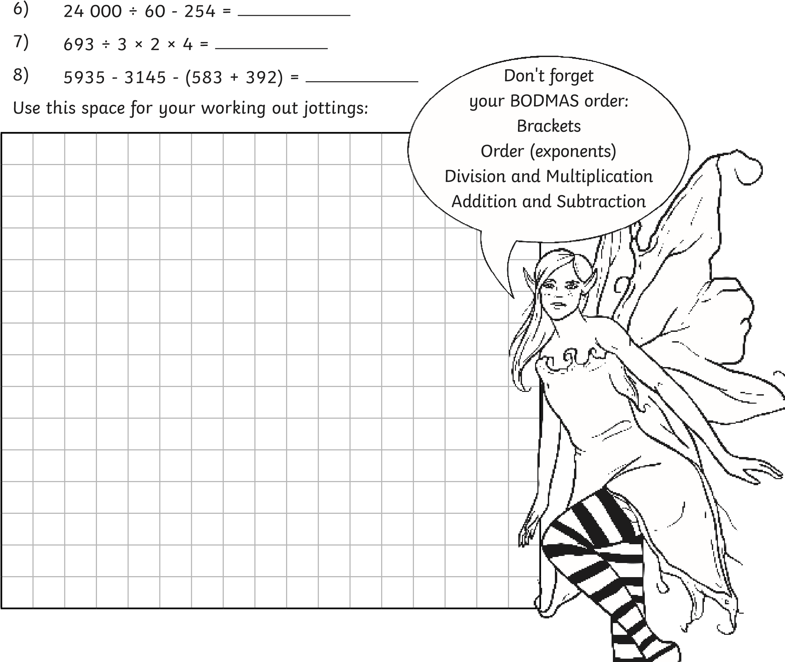

Question | Answer
Complete these calculations using your knowledge of BODMAS.
1 | 256 - 163 + 492 = 585
2 | 315 ÷ 9 × 10 = 350
3 | 592 + 396 + 1943 + 29 894 - 4287 = 28 538
4 | 1959 - 2100 ÷ 6 = 1609
5 | 159 × 3 - (693 - 284) = 68
6 | 24 000 ÷ 60 - 254 = 146
7 | 693 ÷ 3 × 2 × 4 = 1848
8 | 5935 - 3145 - (583 + 392) = 1815

Complete these calculations. Add any missing brackets.
I can explore the order of operations using brackets.
- 9048 - 2294 + 5329 =
- 456 ÷ 19 × 10 =
- 2945 + 3926 + 10 443 + 392 894 - 224 487 =
- 1959 - 1440 ÷ 18 =
- 245 × 4 - 1039 - 593 =
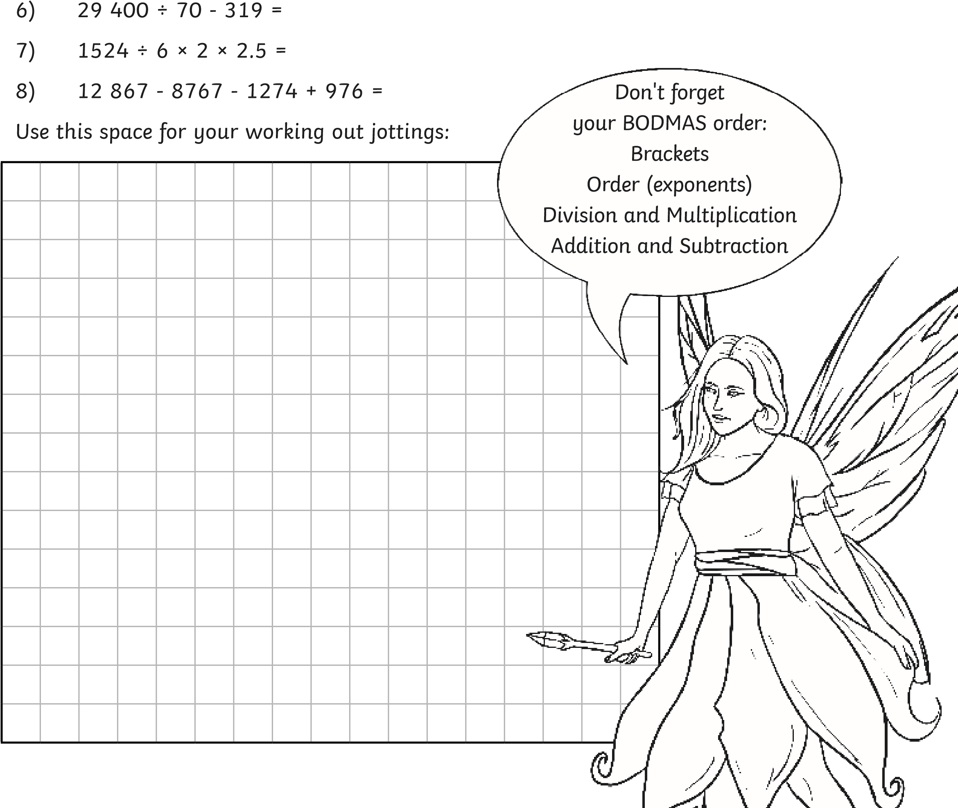

Question | Answer
Complete these calculations. Add any missing brackets
1 | 9048 - 2294 + 5329 = 12 083
2 | 456 ÷ 19 × 10 = 240
3 | 2945 + 3926 + 10 443 + 392 894 - 224 487 = 185 721
4 | 1959 - 1440 ÷ 18 = 1879
5 | 245 × 4 - (1039 - 593) = 534
6 | 29 400 ÷ 70 - 319 = 101
7 | 1524 ÷ 6 × 2 × 2.5 = 1270
8 | 12 867 - 8767 - (1274 + 976) = 1850

Charley says that none of these calculations need brackets. Is he correct? Explain how you know.
- 1524 ÷ 6 × 2 × 2.5 = 1270
- 29 400 ÷ 70 - 319 = 101
- 245 × 4 - 1039 - 593 = 534
I can explore the order of operations using brackets.
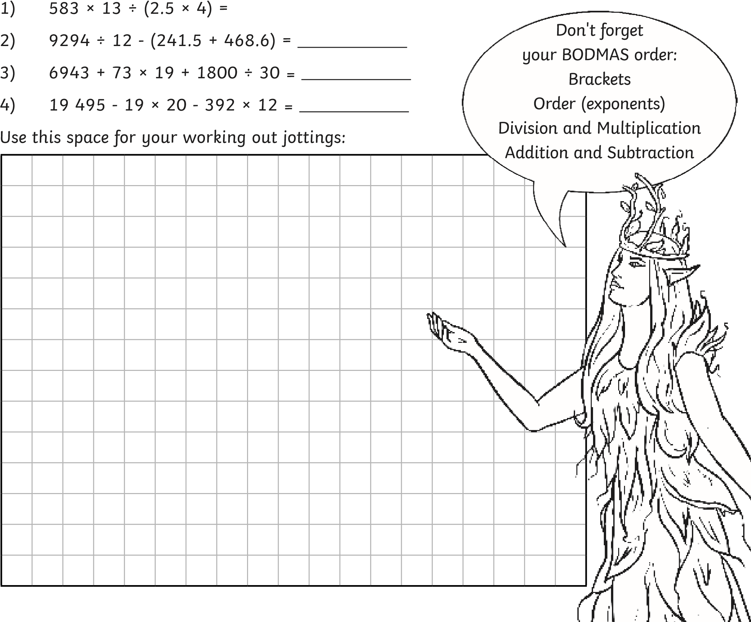
- 1959 - 1440 ÷ 18 = 1879

Question | Answer
Charley says that none of these calculations need brackets. Is he correct? Explain how you know.
1 | 1524 ÷ 6 × 2 × 2.5 = 1270
2 | 29 400 ÷ 70 - 319 = 101
3 | 245 × 4 - (1039 - 593) = 534
4 | 1959 - 1440 ÷ 18 = 1879
 | Charley is incorrect. Calculation 3 needs brackets around 1039 - 593 (as shown above). Without them, the answer would be a negative number as you would be subtracting 1039 and 593 from 980.
Complete these calculations using your knowledge of BODMAS.
1 | 583 × 13 ÷ (2.5 × 4) = 757.9
2 | 9294 ÷ 12 - (241.5 + 468.6) = 64.4
3 | 6943 + 73 × 19 + 1800 ÷ 30 = 8390
4 | 19 495 - 19 × 20 - 392 × 12 = 14 411

Practice your singing and finger-spelling (Greet your family in sign. Ask how they are, what they are doing today. Teach them finger-spelling by playing Hangman)
Plan your day at home. Explain what you will be doing today to your family using signing and finger-spelling.

TIME | ACTIVITY
Have your family ask you for the time throughout the day. Reply in sign.

Design your artwork
Use one of the following shape templates to draw your animal sculpture. |  |  | Remember, different shapes communicate different personalities.  You can turn the shapes any way you like!
This design uses the oval shape. Your design can extend outside the template.
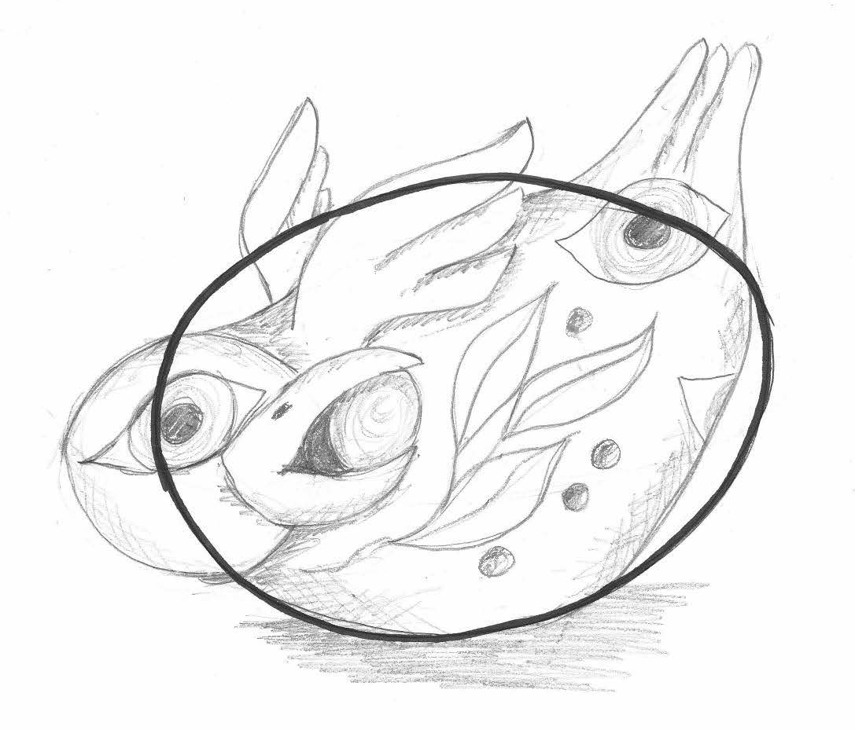
It’s a good idea to think about what you could use to decorate your sculpture once it is dry. This could be paint, collage or found materials.


What other materials (media) will you use to decorate your sculpture?
Explain your choices.
Shape template

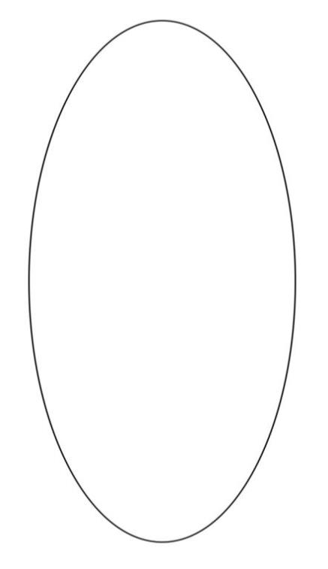

Shape template


Shape template

Shape template

