JOLLY PHONICS
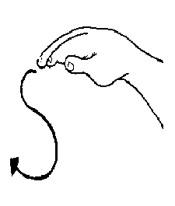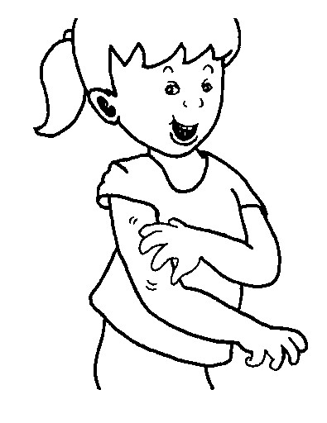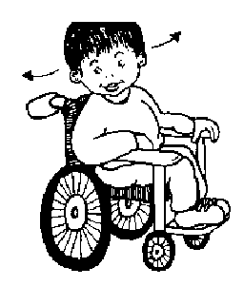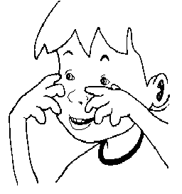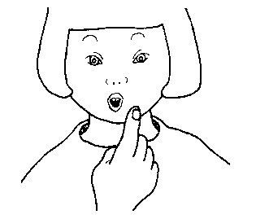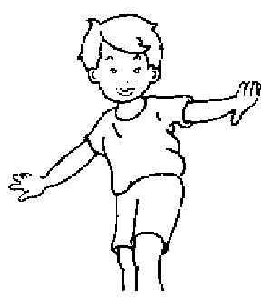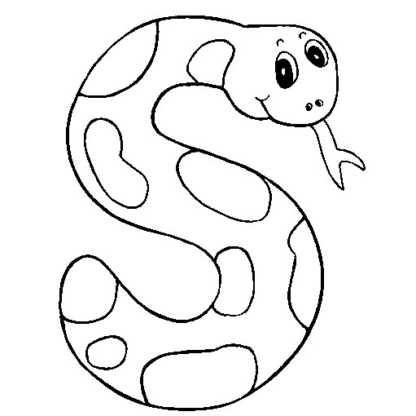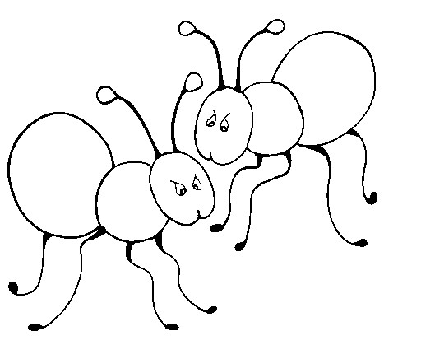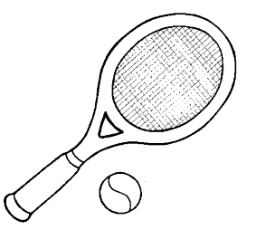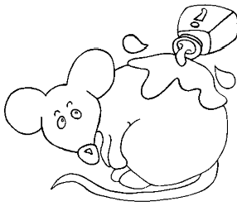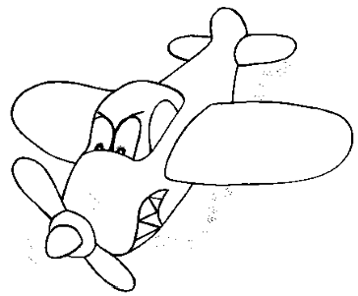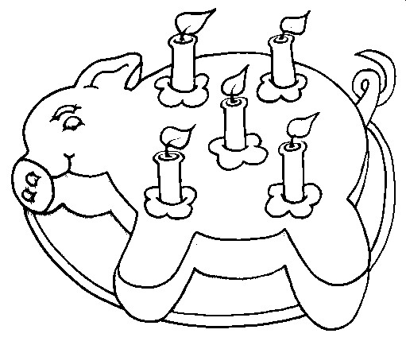

s

Weave hand in an s shape, like a snake, and say
ssssss
.

a

Wiggle fingers above elbow as if ants crawling on you, saying
a, a, a
.

t

Turn head from side to side as if watching tennis and say
t, t, t
, t
.

i

Pretend to be a mouse by wriggling fingers at end of noise and squeak
i, i,
i
, i
.

p

Pretend to puff out candles and say
p, p, p
.

n

Hold arms out at side, as if a plane, and say
nnn
n
n
nn
n
nn
.
!
Group 1

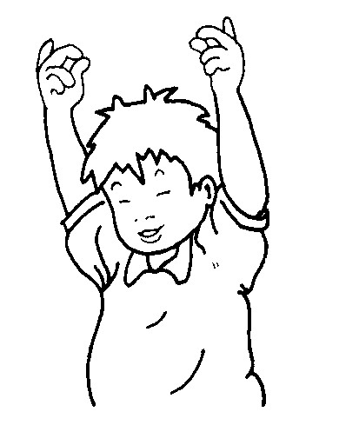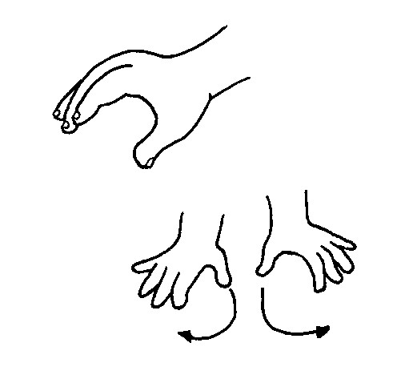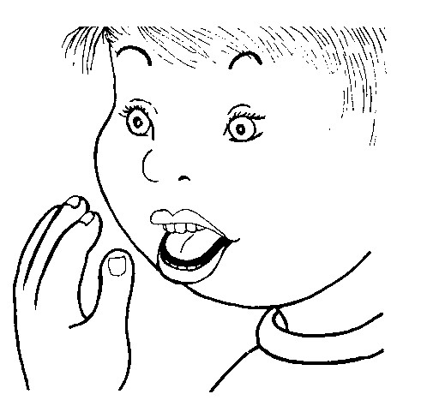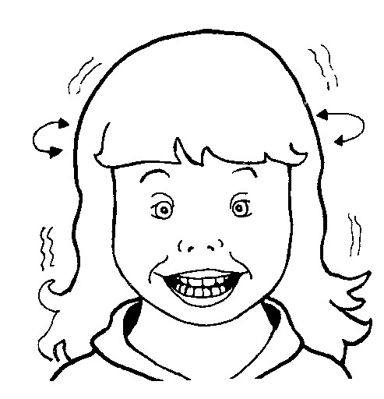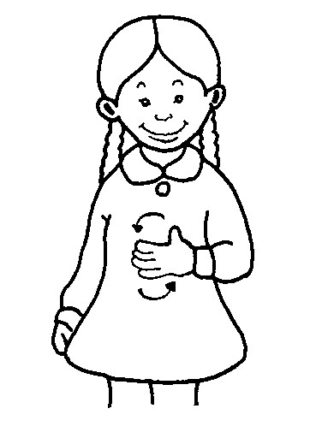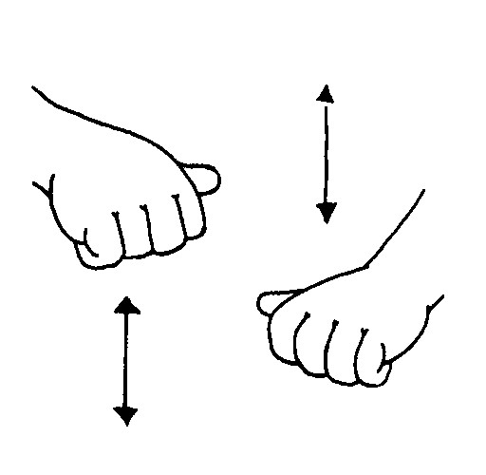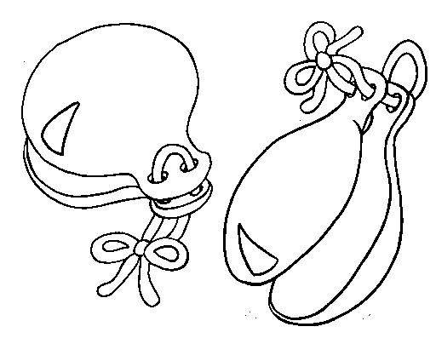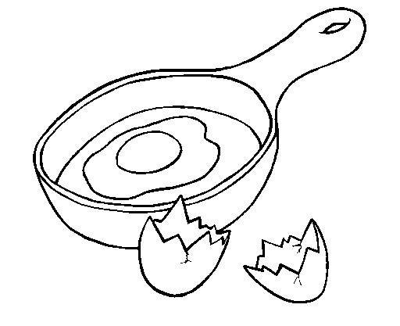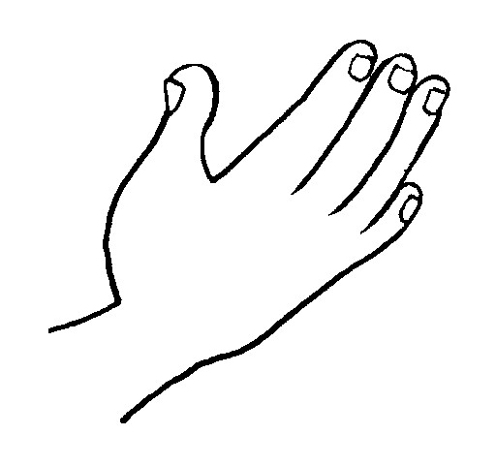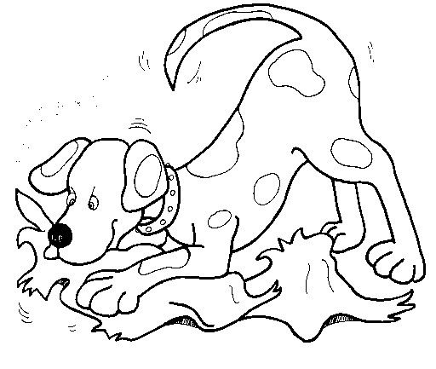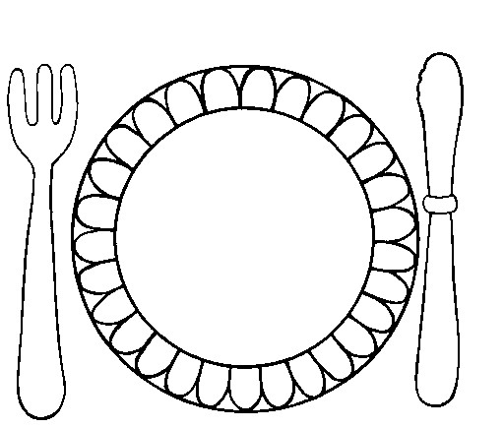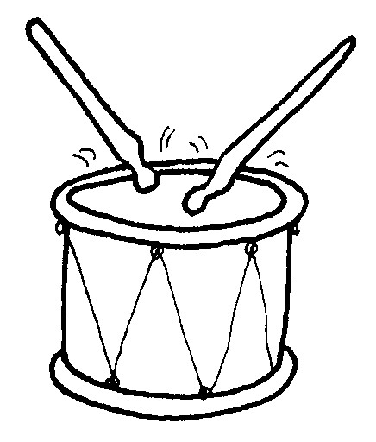

c

k

Raise hands and snap fingers as if playing castanets and say
ck, ck, ck
.

e

Pretend to tap an egg on the side of a pan and crack it into the pan, saying
eh, eh, eh
.

h

Hold hand in front of mouth panting
h, h, h

as if you are out of breath.

r

Pretend to b
e a puppy holding a rag, shaking head from side to side and say
rr
rr
rrr
rr
rr
.

m

Rub tummy as if seeing tasty food and say
mm
mm
mm
.

d

Beat hands up and down as if playing a drum and say
d, d, d, d
.

Group 2

Group 3

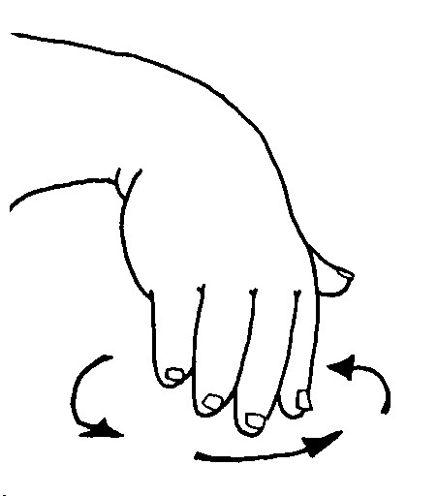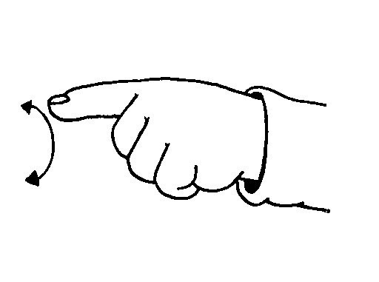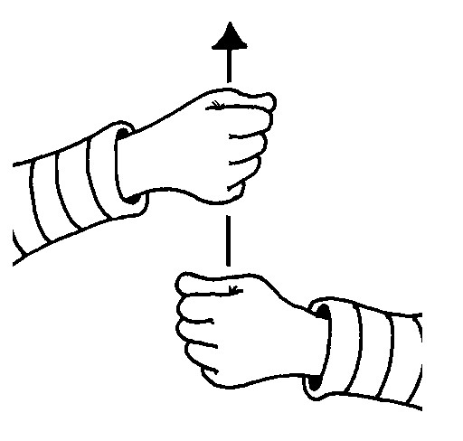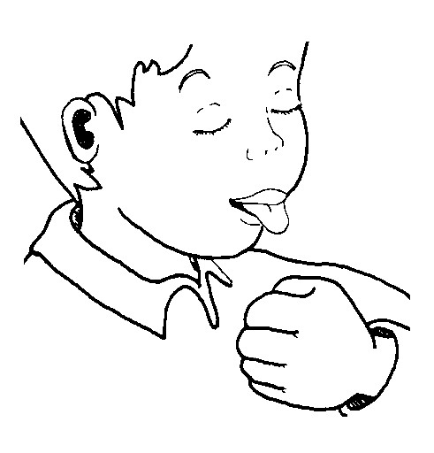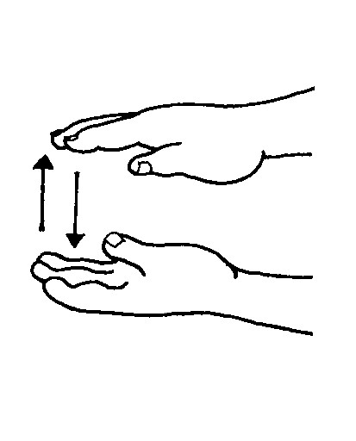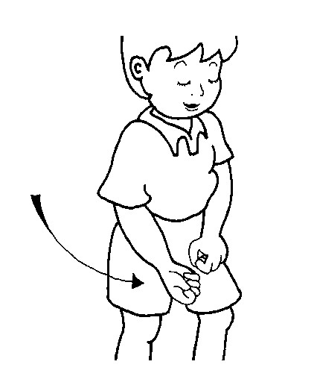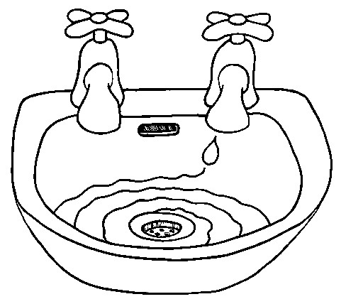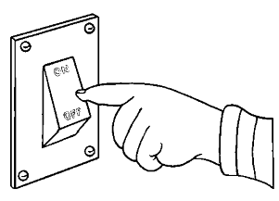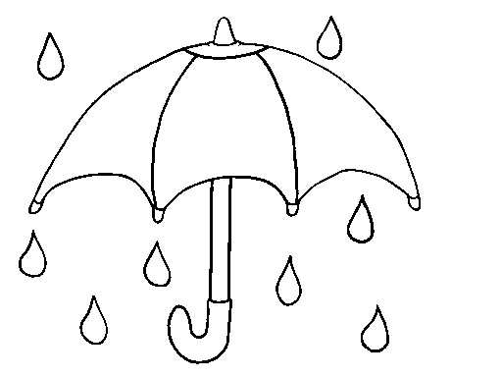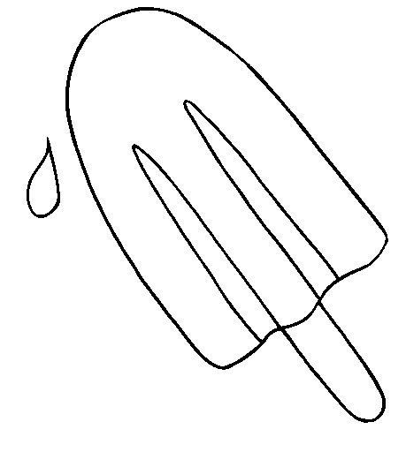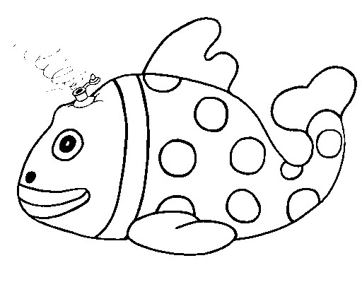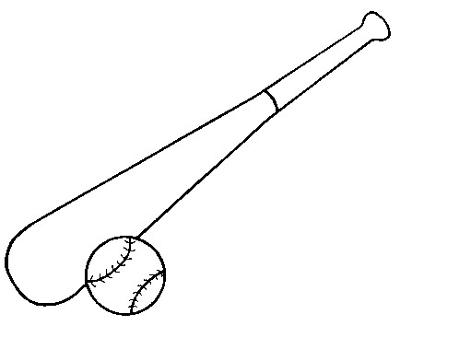
g

Spiral hand down, as if water going down the drain, and say
g, g, g
.

o

Pretend to turn light switch on and off and say
o, o, o, o
.

u

Pretend to be putting up an umbrella and say
u, u, u, u
.

l

Pretend to lick a lollipop and say
l, l, l, l
.

f

Let hands gently come together as if toy fish deflating, and say
ffffff
.

b

Pretend to hit a ball with a bat and say
b, b, b, b
.

!
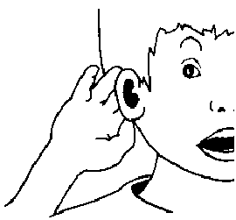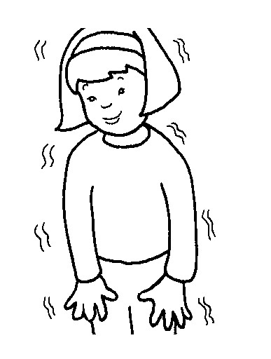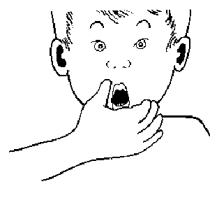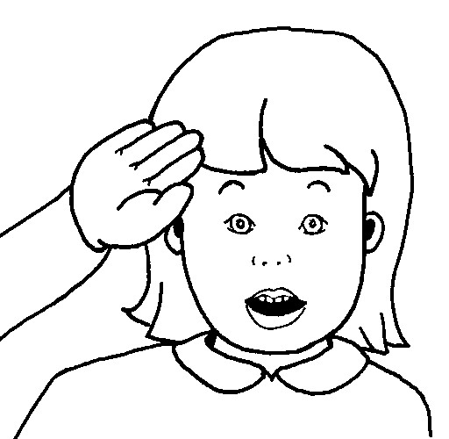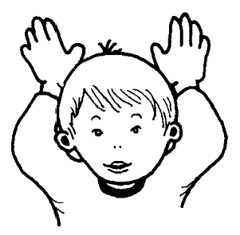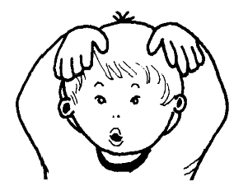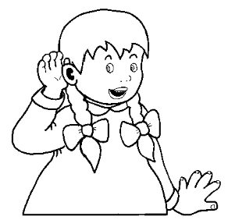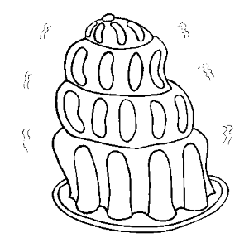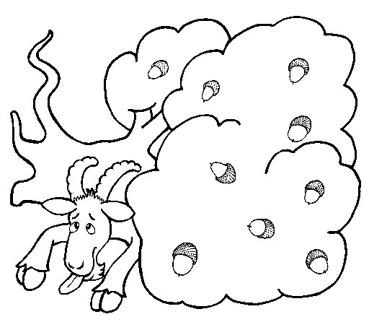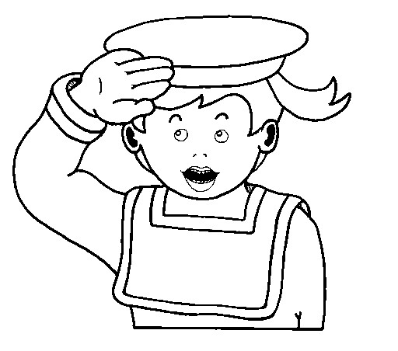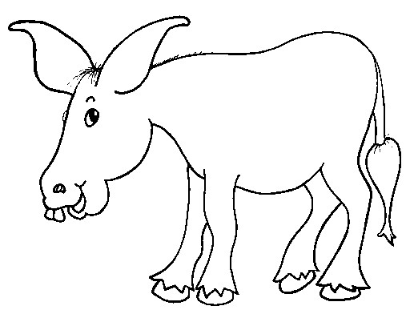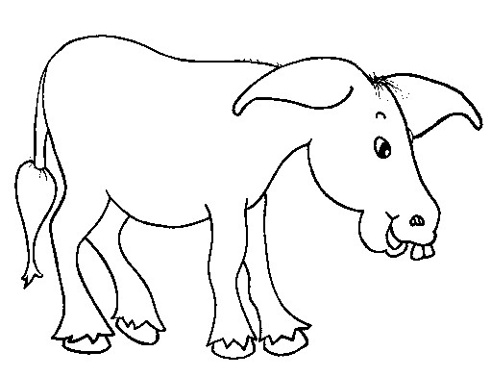
a
i

Cup hand over ear and say
ai,
ai, ai
.

j

Pretend to wobble on a plate and say
j, j, j
.

oa

Bring hand over mouth as if something terrible has happened and say
oh!

ie

Stand to attention and salute, saying
ie
,

ie
.

e
e

Put hands on head as if ears on a
donkey.

Move them up as you say the
ee

in
eeyore, eeyore
.

o
r

Put hands on head as if ears on a donkey.

Move them up down as you say the
or

in
eeyore, eeyore
.
!
Group 4

SIGHT WORDS

PINK WORDS RED WORDS
is here the up comes mum on
come look at said a little to

I am too big no hungry in

SIGHT WORDS TEXTS

Night in the Garden:

A rabbit is in the garden. A cat is in the garden. A snail is in the garden.
A worm is in the garden. A spider is in the garden.
A frog is in the garden. A bat is in the garden.

Balloons:
“Here is a red balloon,” said the clown. “Here is an orange balloon,” said the clown.
“Here is a yellow balloon,” said the clown. “Here is a green balloon,” said the clown.
“Here is a blue balloon,” said the clown. “Here is a purple balloon,” said the clown.
“Here is a pink balloon,” said the clown.

ENGLISH
RHYMING STORY:
The Very Itchy Bear:
Bear is here… and here is Flea (but Flea’s a little small to see). This is Flea about to bite, but not because he’s impolite. He’s biting Bear to say, “Hello!”. Biting high and biting low.
This is Flea biting Bear under here and over there. Biting, biting everywhere! SPLASH!
This is Bear and this is Flea, floating, floating out to sea. This is Bear not quite sure if Flea is with him anymore. This is Flea reminding Bear… that Flea has not gone anywhere. This is Bear flicking Flea off his fur and out to sea. This is Bear all alone, frightened now he’s on his own.
This is Bird and this is Bear and Flea is way, way over there. This is Flea about to see how scary hungry birds can be! This is Bear in the sea swimming fast to rescue Flea. Flea is happy Bear can swim. This is Flea not biting him. This is Flea and this is Bear. Together they go everywhere.

RHYMING WORD GROUPS
tap map sad / tip lip bin
pin tin cat / can man did

ALPHABET CHART
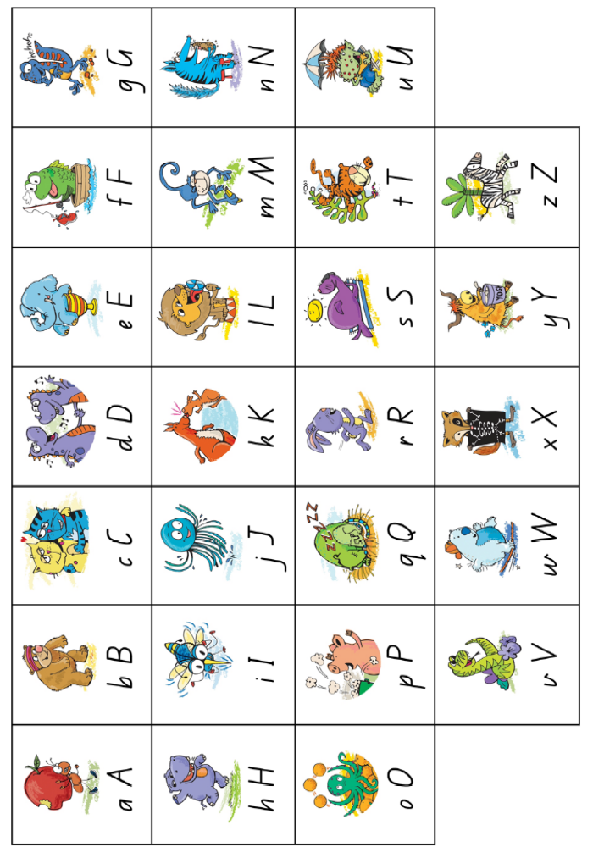

NUMBER CHART
The ability to write numbers is a handwriting skill and in no way reflects a child’s understanding of particular numbers.
Reversal of some or all numbers is common with immature writers. Consistently modelling correct forms, giving immediate feedback on student’s attempts and encouraging continued effort will solve this problem for most students.
Say aloud the poems below as you demonstrate how to write each of the numbers. Encourage students to say the poems as they write the numbers.
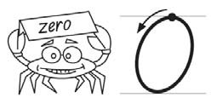 | Start at the top and left we go  All the way round to make a zero.
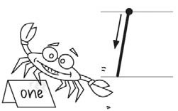 | Nothing’s faster than a one. Draw a line down and it’s done.
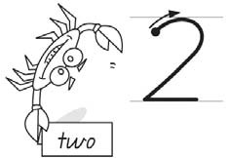 | The secret is: just let it flow. Curve around then down you go.  Across the floor then thanks to you We have a lovely number 2.
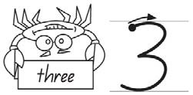 | Make your pencil do a swerve  Then race around another curve.  Before we all cry out ‘Yippee!’  You have made a number 3.
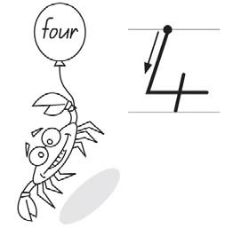 | If you want a number 4 start at the top  Head to the floor go across — draw a little line  Your number 4 is looking fine.
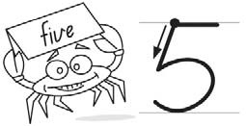 | To make a 5, slide it down  Next, send it curving round  Almost there — but don’t you stop  Until you’ve put a hat on top.
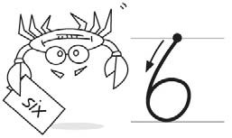 | Straight little back and big round tummy  Number 6 looks very funny.
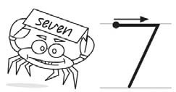 | Left to right and down we run  7 is standing. That was fun.
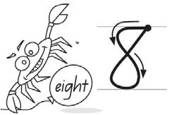 | Make an S and then go straight  Back to the top, you’ve made an 8.
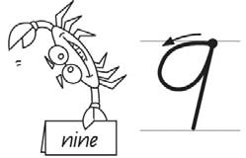 | First go left and then around  To finish the 9, go up then down.
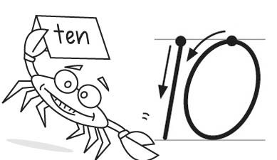 | Draw a 1, a nice straight line.  Draw a 0, that looks fine.  Stamp your feet and wave your pen.  You have drawn a number 10.

TEN FRAMES
X | X | X

X | X | X | X
X | X | X

X
X | X

X | X | X | X

X | X | X | X | X
X | X | X

 |  |  | X | X
X |  | X

Playdough Recipe

Ingredients
- 1 cup salt
- 3 cups plain flour
- 60ml (1 tbsp) vegetable oil
- food colouring
- 250ml (1 cup) water

Method
1.Mix all the dry ingredients and add oil.
2.Add the food colouring to water.
3.Slowly add the water until the desired consistency is reached.
4.Kneading will help to improve the texture, so let your kids get into it!

Wrap the play dough up well after your child has finished playing with it in a ziplock bag or clingwrap

OTHER
Science – Weather discussion questions:
What is the weather today?
What is the temperature? (Warm or cold)
What senses did you use to know that? (see, hear, taste, feel/touch, smell)

Looking under! Minam Apang
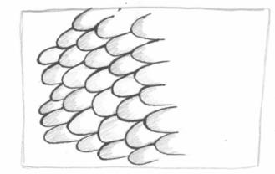 | 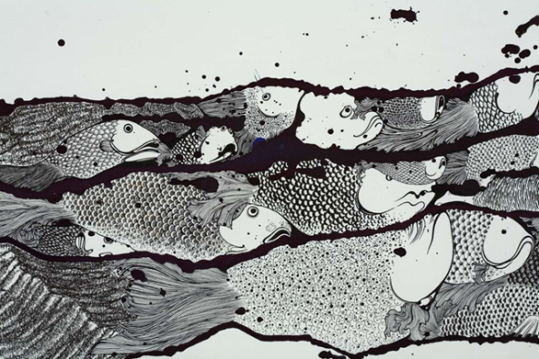  Minam Apang  The sleeping army may stir (detail), 2008  Minam Apang  India b.1980  The sleeping army may stir (detail) 2008  Ink and synthetic polymer paint on fabriano cold-pressed paper 70 x 240cm  Collection : Isabelle Levy and Geraldine Galateau, Paris Courtesy: The artist and Chatterjee & Lal, Mumbai | 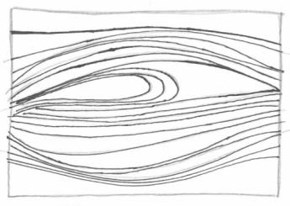
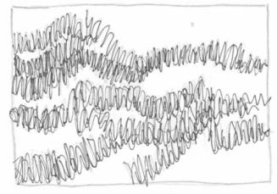 |  | 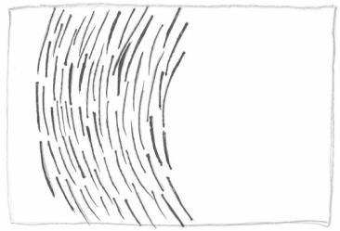
The patterns in the boxes are from this artwork.
Can you find the patterns on the fish?
Draw a line to connect the pattern to where you can see it in the artwork!

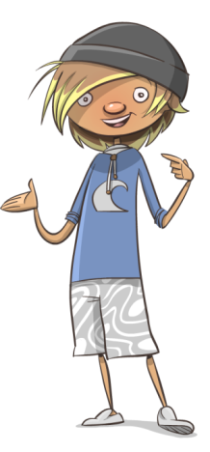
Draw a shape or a line and repeat it to create your own patterns.
The more times you repeat the shapes, the more detailed your pattern will be!

These fish are missing their scales!  Create patterns on their bodies. | 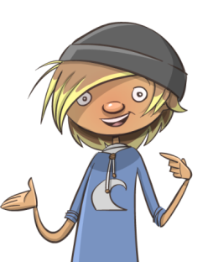  Add bright colours like fish under the sea.
